|  |
| --- |
| 1.jpg  **Assessment Cover Sheet** |

**Due Date**

22-May-2024

**Course Code**

IT8416

**Assessment Title**

Group Project

**Course Title**

Data Mining

**Internal Moderator’s Name**

Dr. Shomona Jacob

**External Examiner’s Name**

-

Not must-pass

Group

Uncontrolled

**Assessment Type**

**Instructions:**

1. This cover sheet must be completed (section in red below) and attached to your assessment before submission in hard copy/soft copy.
2. The time allowed for this assessment is 7 weeks.
3. This assessment carries 35% marks distributed to a total of 3 questions (Database/DAL, FormApp, and WebApp) assessing CILO 1,2,3,4, and 5.
4. The materials allowed for use in this assessment are Moodle Resources, Slides, Lab Manual, and Lab Solutions.
5. The **use of generative AI tools is strictly prohibited**.
6. References consulted (if any) must be properly acknowledged and cited.
7. The assessment has a total of 14 pages.

**Programme Title**

**Learner ID**

202002514 – 201901982 - 202001559

**Date Submitted**

22/5/2024

**Learner Name**

BICT -Database

IT8416

Fedaa Abdulwahab - Maryam Alali - Yaqeen Aljamri

**Programme Code**

**Lecturer’s Name**

Sini Raj Pular

***By submitting this assessment for marking, I affirm that this assessment is my own work.***

**Learner Signature**

Sini Raj Pular

Do not write beyond this line. For assessor use only.

**Assessor’s Name**

Sini Raj Pular

**Marking Date**

**Maks Obtained**

**Comments:**

Contents

Task 1 – Problem Statement Formulation and definition 3

Task 2 - Selection of an Appropriate Data Set (Data Collection) 4

Source of dataset: 4

Visualization 5

Distribution of data 10

Task 3 -Preparation and Pre-processing of Selected Data 11

Task 4- Building Data Mining Models 21

Task 5 -Evaluating Data Mining Models 27

Evaluating Models: 27

K-NN Classification Evaluation: 27

Decision Tree Evaluation: 28

Random Forest: 28

Ensemble Model Evaluation: 28

Task 6 – Inferences, Recommendation and Reflection 30

Miscellaneous 32

GitHub Link: 33

Video Link: 33

References: 34

# Task 1 – Problem Statement Formulation and definition

Motivation and Project Definition:

Heart disease, a leading cause of death globally, often strikes silently. Early detection is crucial for effective treatment and improved outcomes. However, traditional diagnostic methods can be expensive, time-consuming, or invasive. This project explores the potential of machine learning to address this challenge. By building a model that analyzes patient data, we aim to predict the likelihood of heart disease, promoting earlier intervention and potentially saving lives.

Objectives:

We use data mining to unlock the secrets hidden within past heart disease cases. By analyzing trends and patterns in this data, we can create a powerful case study. This case study won't just reveal the root causes of heart disease, but also shed light on the most effective ways to manage and potentially even prevent it. This knowledge can empower individuals to take proactive steps towards a healthier heart and equip healthcare professionals with valuable insights to personalize treatment plans for their patients. Ultimately, this project aims to turn the tide against heart disease by leveraging the power of data and fostering a future of better heart health for all.

Expected Result:

At this initial stage, our expected results are open to refinement based on further research. However, we anticipate:

* Developing a model with high accuracy: This model should effectively predict the likelihood of heart disease based on patient data points.
* Identifying key risk factors: By analyzing the model's predictions, we hope to gain insights into the most significant factors contributing to heart disease risk.
* Potential for early intervention: Early detection through the model could allow for preventive measures and potentially reduce healthcare costs associated with advanced heart disease.

# Task 2 - Selection of an Appropriate Data Set (Data Collection)

## Source of dataset:

Our group have selected this dataset because it meets all the requirements, and it consists of 14 attributes and 1026 instances. The dataset dates are from 1988 and has four databases: Cleveland, Hungary, Switzerland, and Long Beach V. However, only the Cleveland database has been used to date by ML researchers to figure out if a patient has a heart disease or not in order to have a better understanding of the problem. Also, there is missing data and redundant attributes in the dataset. (Heart Disease Dataset. 2019. Retrieved from https://www.kaggle.com/datasets/johnsmith88/heart-disease-dataset).

Moreover, by analyzing the chosen dataset of the Cleveland and making a proper visualization we could gain a deep insight of the factors related to heart disease to help the doctors in the city to diagnosis the cases the related t has a heart disease and put an adequate treatment plan for the future and reduce the number of heart disease patients.

The dataset has two types of attributes: qualitative and quantitative. Such as: age, sex, trestbps, chol, and slope. The number of attributes is 14 and the number of instances is 1025. Also, the dataset has redundant and missing data as they required for further data cleaning.

## Visualization

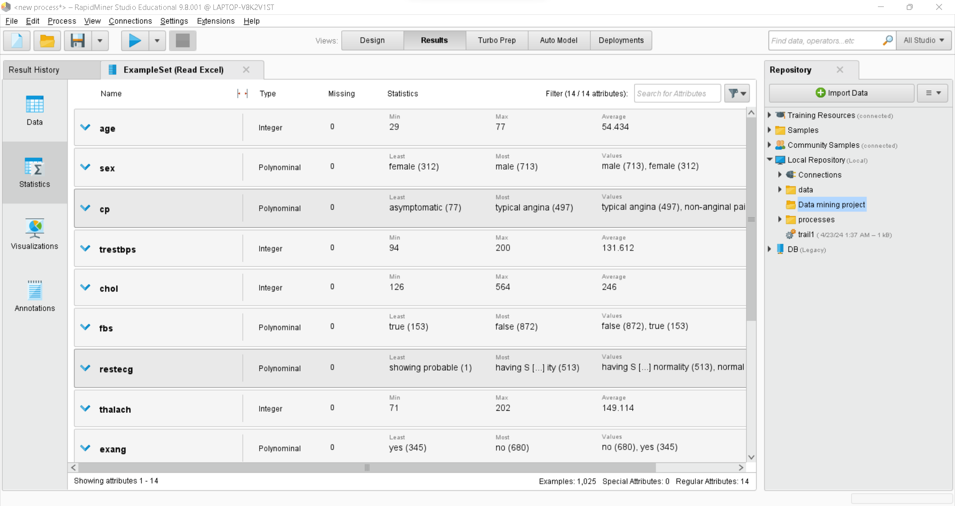

Figure 1.1: shows statistics about the attributes, data type, missing and duplicated values.

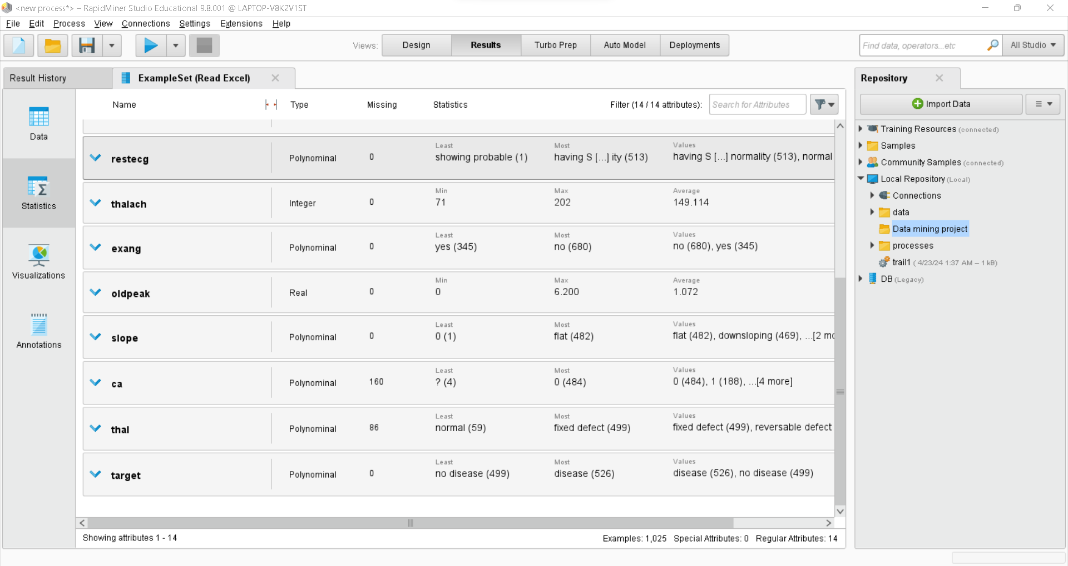

Figure 1.2: shows statistics about the attributes, data type, missing and duplicated values.

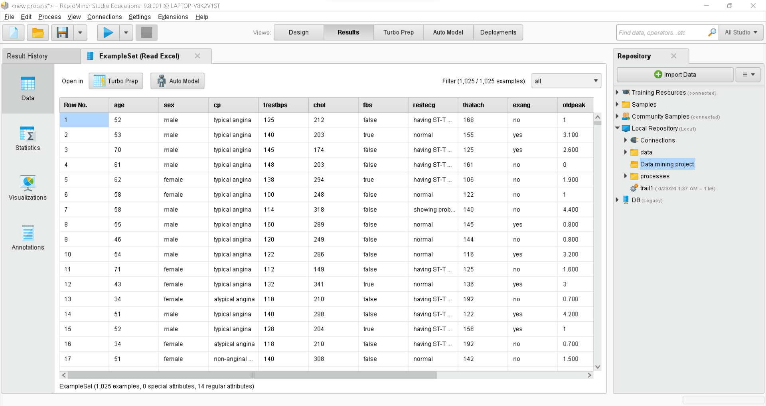

Figure 2.1: shows some data from the dataset with missing values and redundant data.

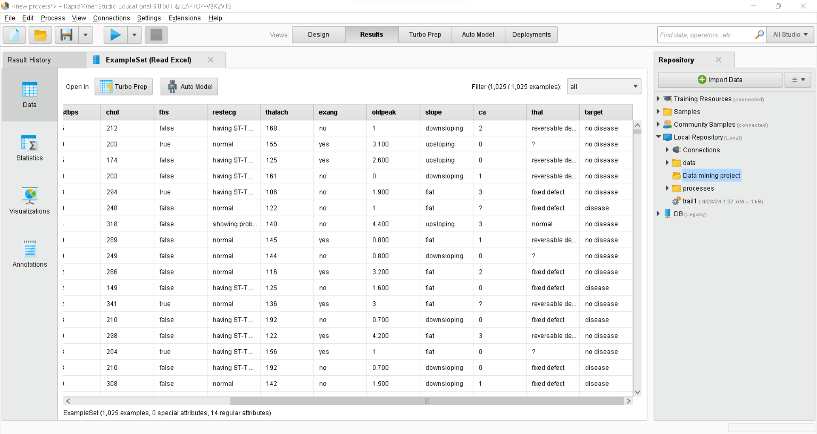

Figure 2.2: shows some data from the dataset with missing values and redundant data.

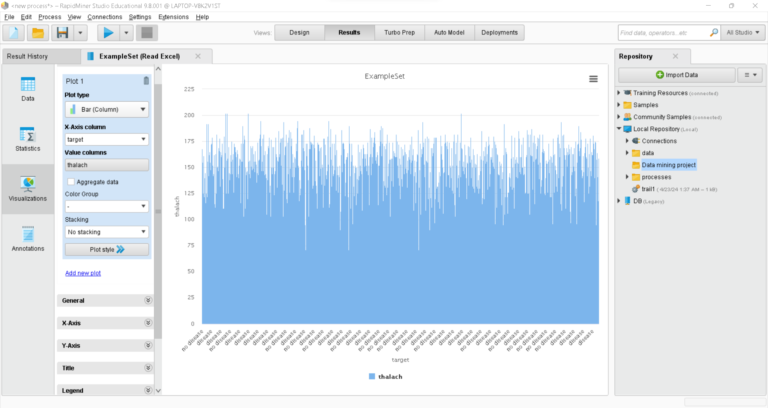

Figure 3: shows a graph that represents the relationship between the thalach (maximum heart rate achieved per minute) and the presence of heart disease in the patient. The maximum heart rate was achieved is 202 and the disease existed, and the minimum heart rate was 95 and the disease did not exist. As a result, we could say that if the thalach in the patient is high the heart disease will mostly exist.

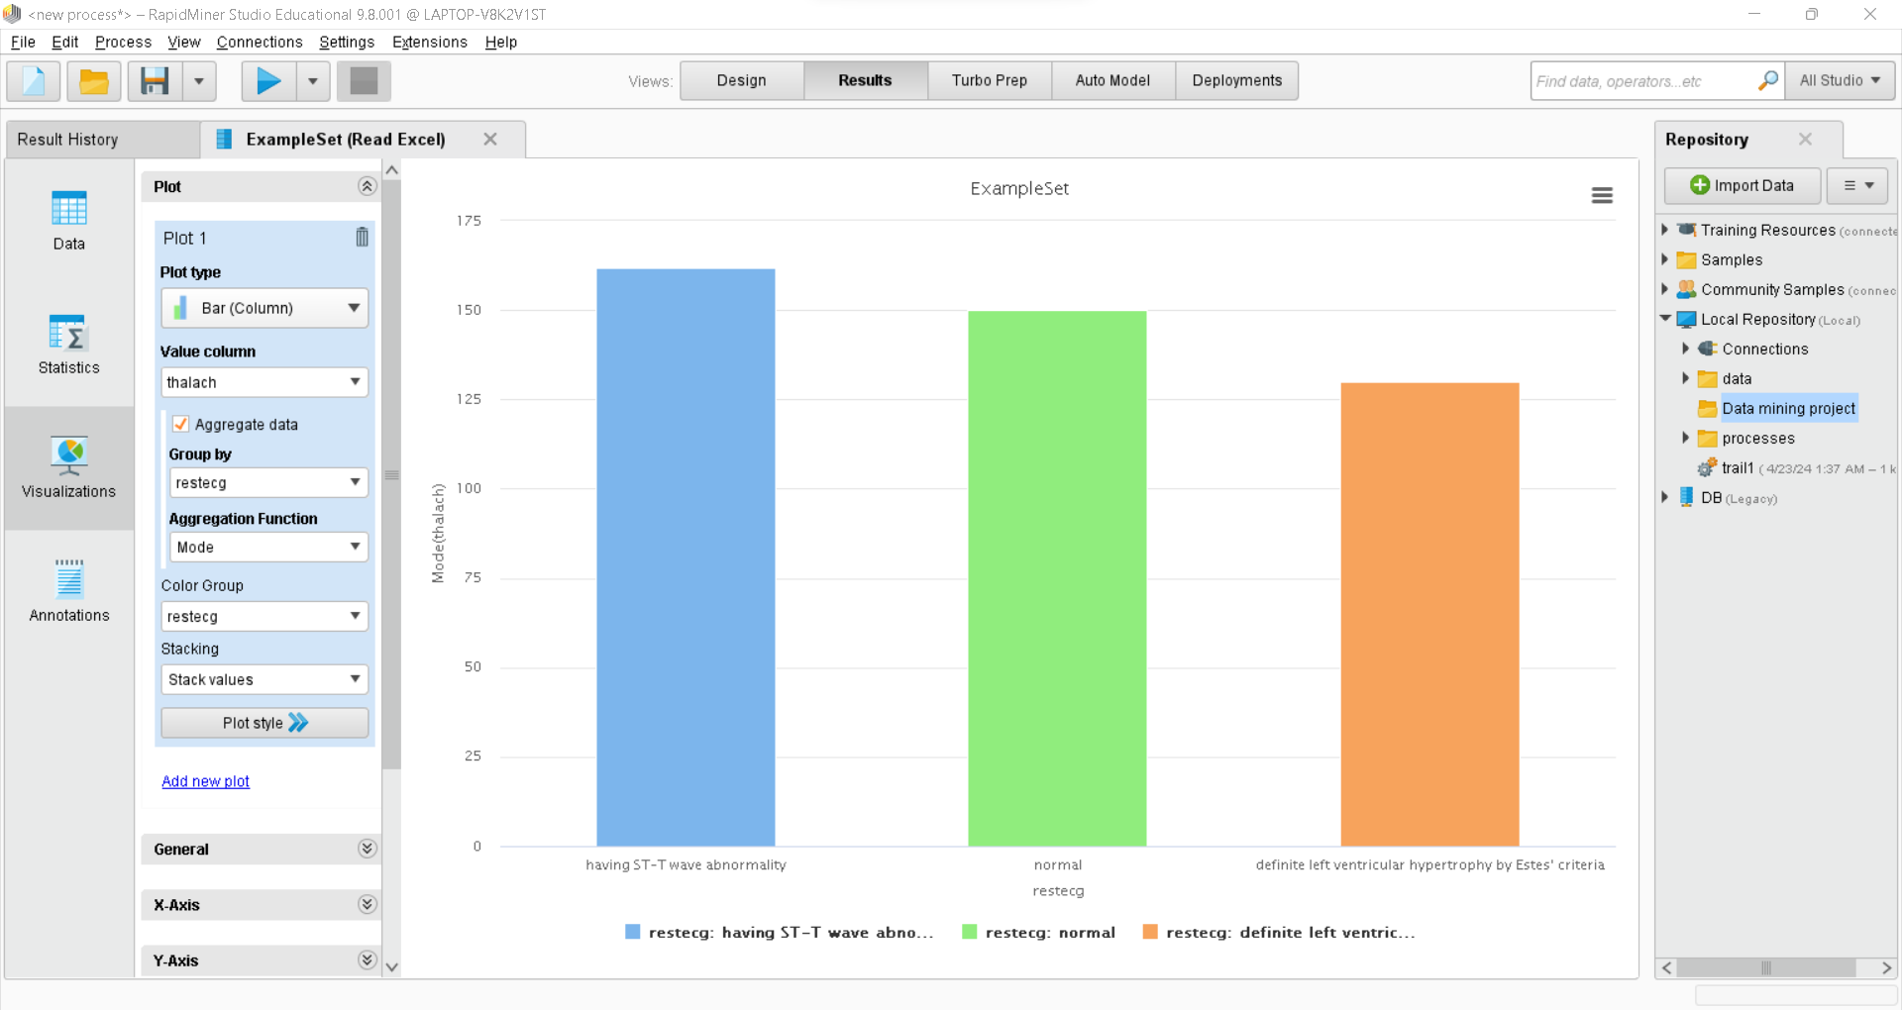

Figure 4: shows a bar graph that illustrates the most repeated number of thalach according to the restecg (resting electrocardiographic results). The blue bar shows that most patients with a thalach of 162 having ST-T wave abnormality. The green bar shows that the normal restecg was in the patients having a 150 thalach. The orange bar indicates that the patients with a 130 thalach are having a definite left ventricular hypertrophy by Estes' criteria.

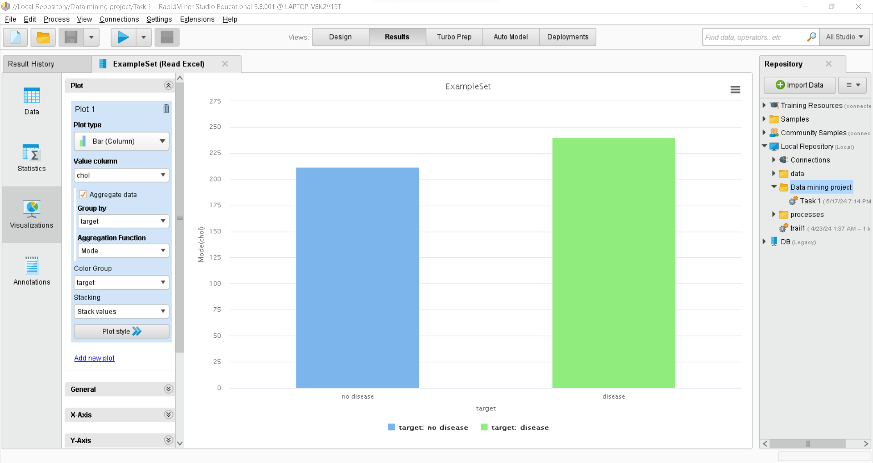

Figure 5: shows a bar graph that illustrates the most repeated number of chol (serum cholestoral in mg/dl) according to the target (the presence of a heart disease in the patient). The blue bar shows that most patients with a chol of 212 do not have heart disease. Meanwhile, the green bar shows that most heart disease exists in the patients that having a chol of 240.

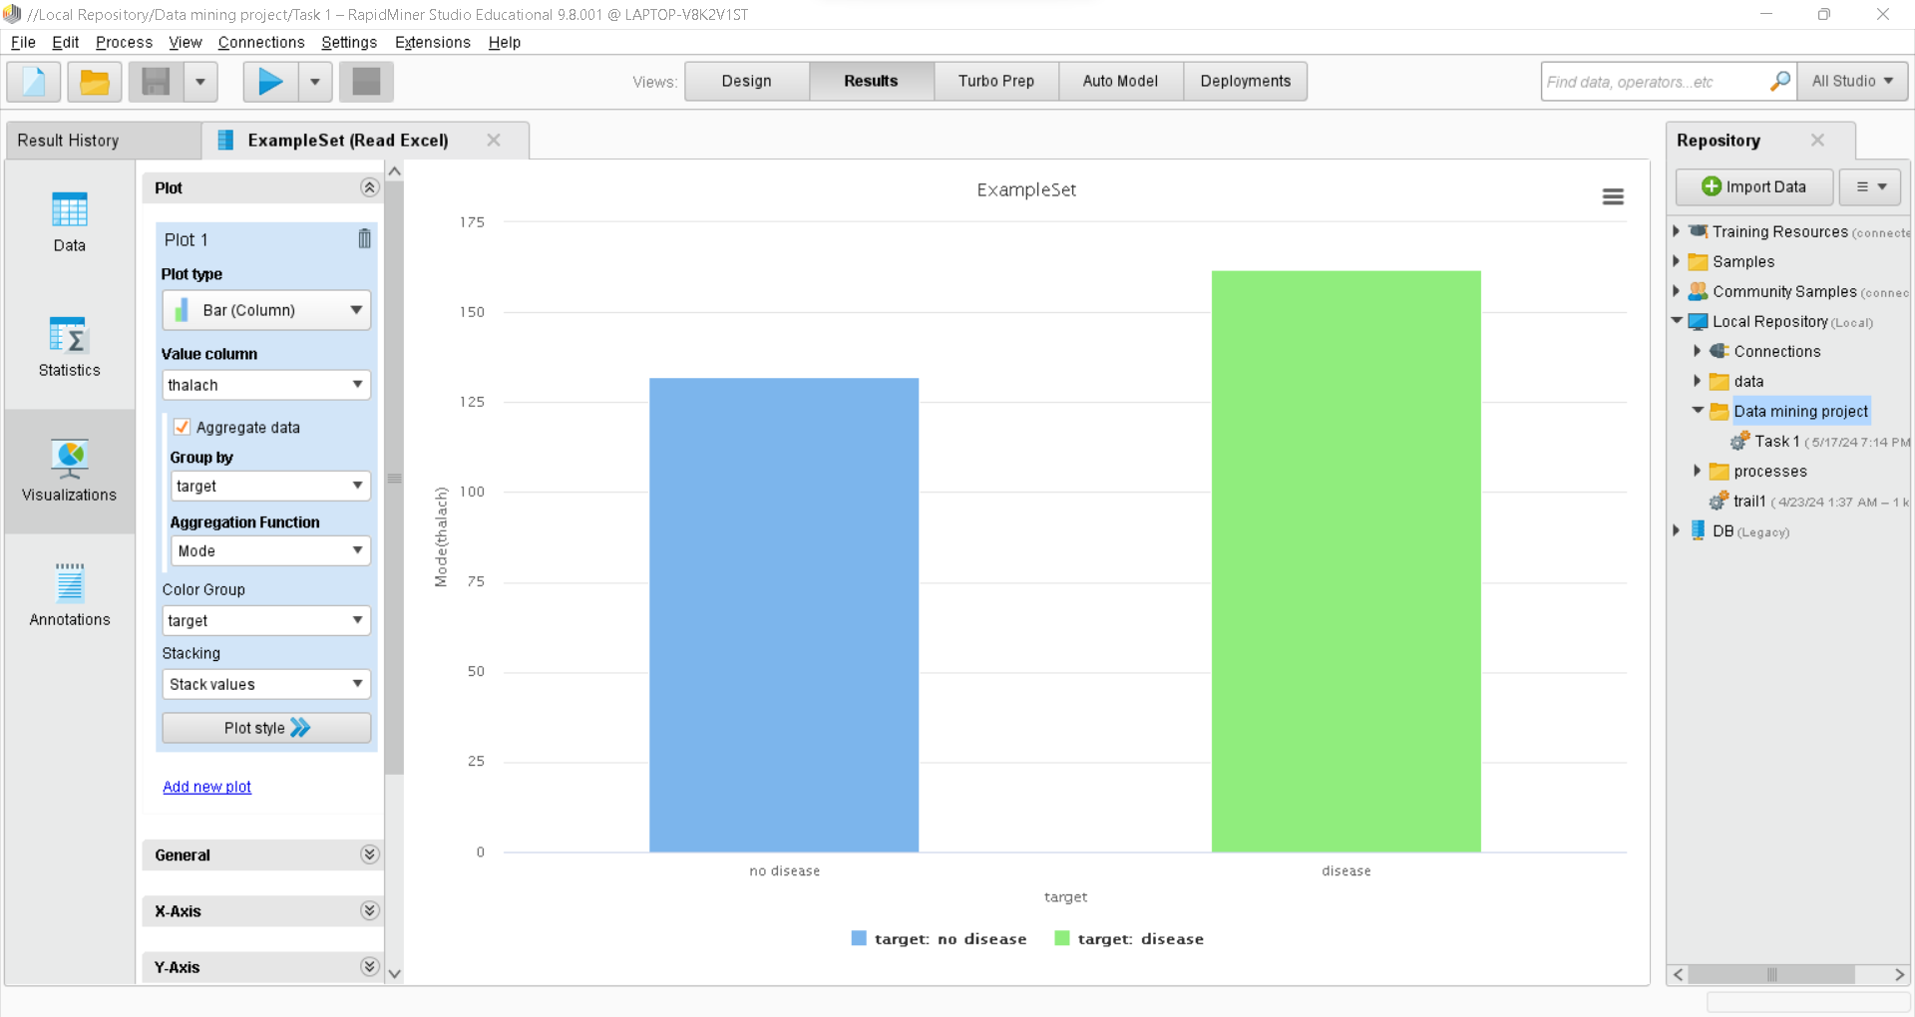

Figure 6: shows a bar graph that illustrates the most repeated number of thalach according to the target. The blue bar shows that most patients with a thalach of 132 do not have heart disease. Meanwhile, the green bar shows that most heart disease exists in the people that have a thalach of 162.

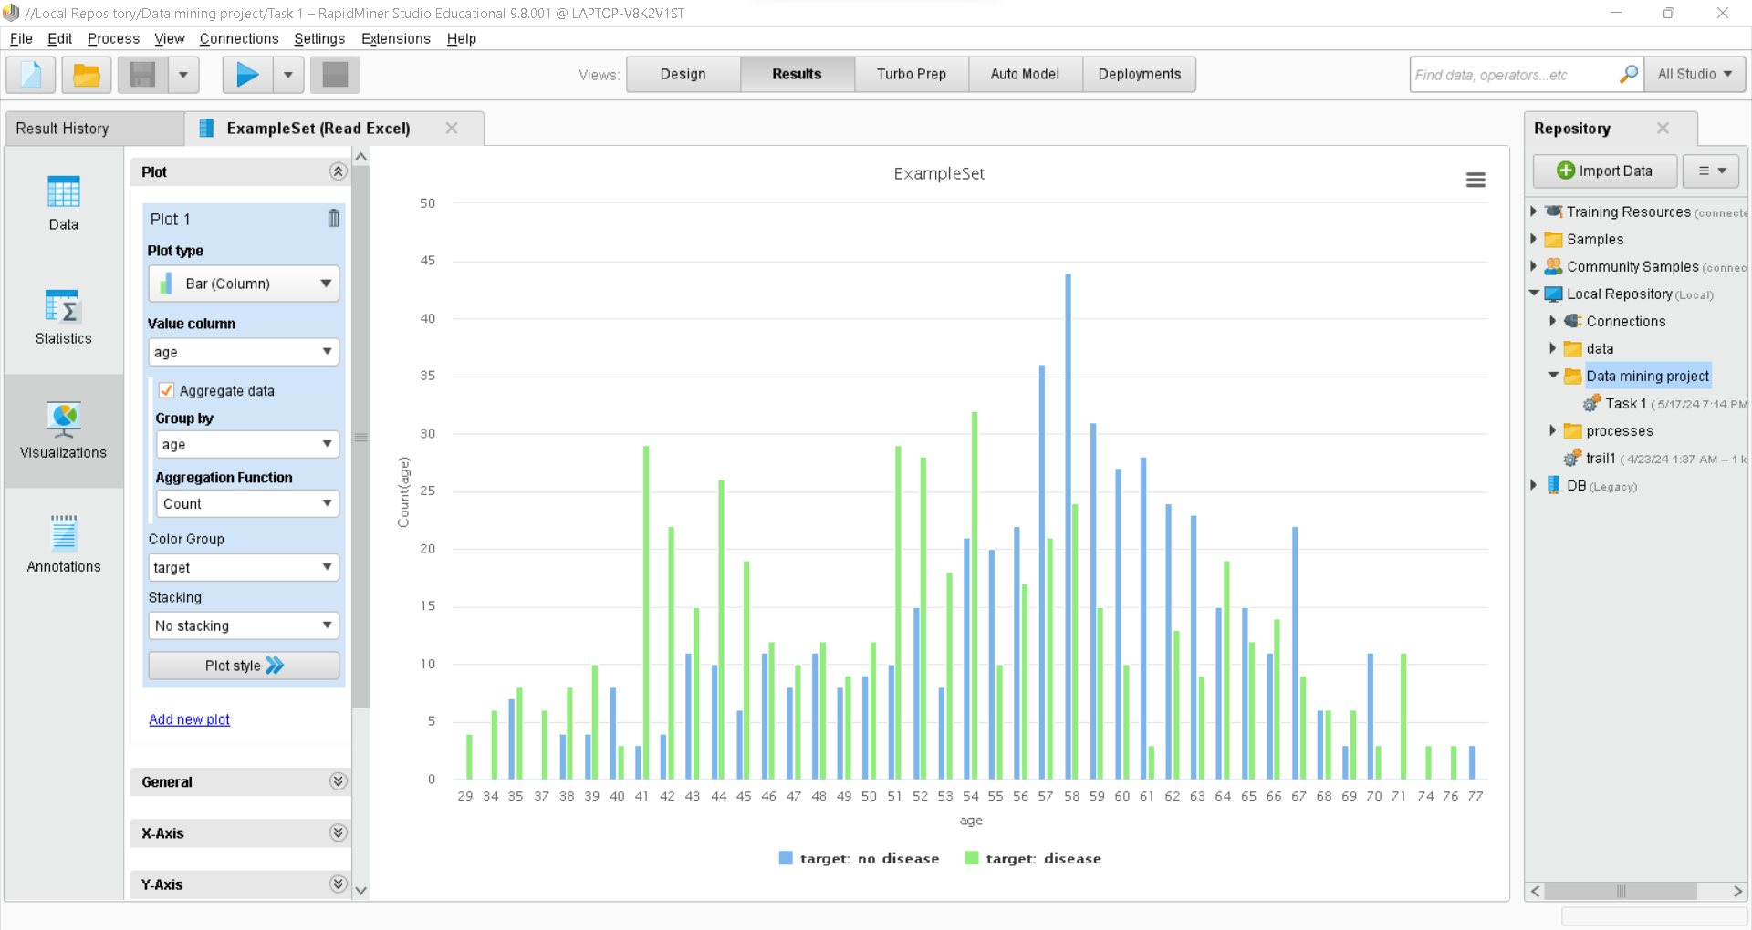

Figure 7: shows a bar graph that illustrates the most repeated ages in the dataset that having or not having heart disease starting from age 29 to age 77. And the most repeated age was 58.

## Distribution of data

**Skewness:**  
The skewness of the data in figure 7 is going towards the left side as the most repeated age is 58 followed by 57 and 54.

**Central Tendency:**  
The central tendency is consisting of mean, median, and mode. The mean helps to determine the average age of people that have heart disease. The median will represent the middle value, and the mode will show the most repeated values.

**Outliers:**  
The outliers are the values they will be outside the average of statistic. By finding the outliers the quality of the data could be further improved.

**Range:**  
By finding the range of the dataset we could find most age that has a heart disease.

**Spread:**  
The spread of data by using standard deviation will help to determine the how the data are far from the center.

# Task 3 -Preparation and Pre-processing of Selected Data

Data pre-processing is a method to transform the initial dataset into an understandable format. Also, data pre-processing is a way to improve the efficiency of data in data mining. The actions that could be used in data pre-processing is cleaning, integration, transformation, and reduction to insure the consistency of data. Moreover, KDD refers to the term (Knowledge Discovery) which is a process to extract knowledge from a big dataset. The aim of KDD is to find the hidden patterns in the data in order to make the right decisions and predictions. In addition, KDD several steps in data mining to take knowledge from a large dataset such as:

Data selection: this is the first step to select the proper dataset to be analyzed in KDD process.

Data pre-processing: this is the second step in KDD process which aims to clean the data, find any outliers, and remove them, remove missing and redundant data to improve the overall quality of the data.

Data transformation: after doing the pre-processing step, it is time to transform the data to a form that can be analyzed using data mining techniques such as reducing the dimensionality of data and do the normalization of data.

Data mining: data mining techniques will be applied on the transformed data to find the hidden patterns. The techniques that could be used are clustering, classification, association rule mining, and anomaly detection.

Pattern evolution: the next step is to evaluate the patterns to figure out if they are useful or not.

Knowledge representation: in this step the knowledge that has been extracted will be presented in a way that can be understood easily by humans using any visualization methods.

Deployment: this is the final step to deploy the knowledge from data to practical applications.

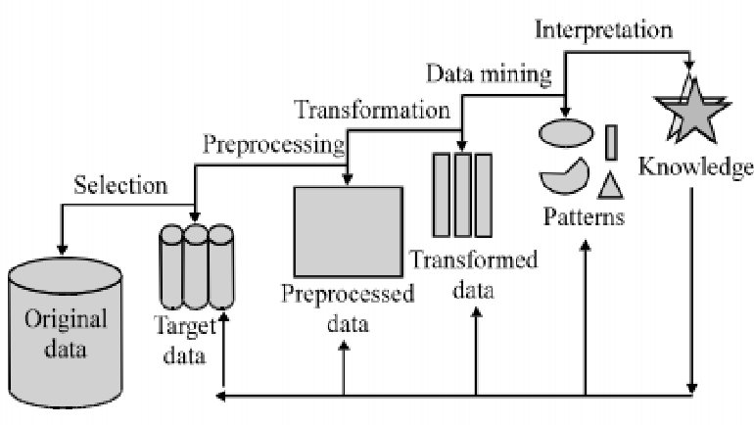

Figure 8: shows the process of data pre-processing using KDD Architecture Diagram.

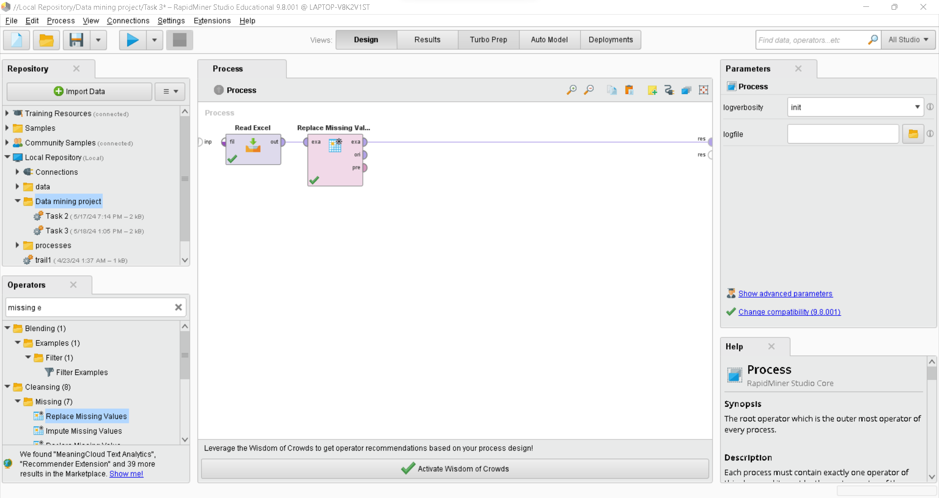

Figure 9: shows the usage of Replace Missing Values operator that has been implied on the dataset.

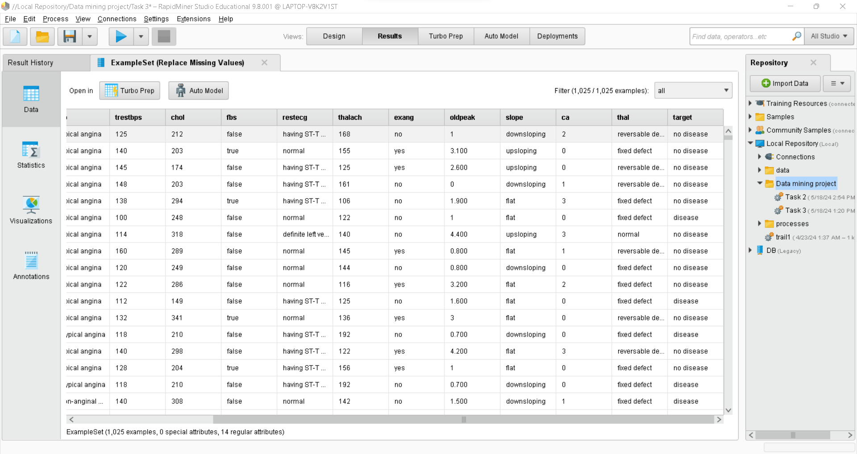

Figure 10: shows that the missing values have been replaced with the average value of the columns that have missing values.

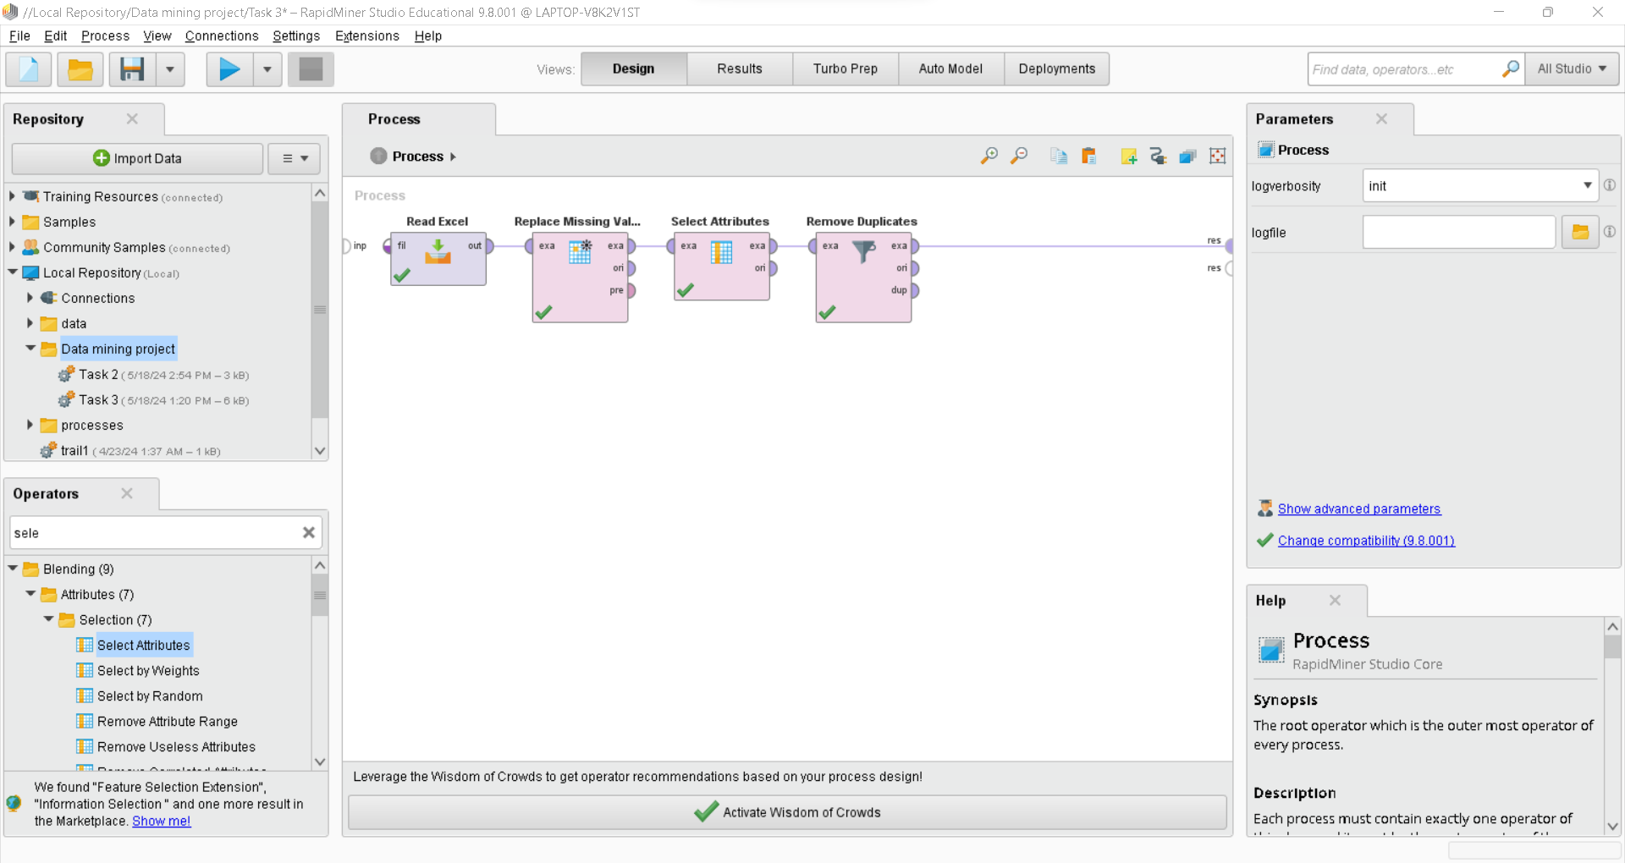

Figure 11: shows that the duplicated values have been removed from the dataset using Select Attributes and Remove Duplicates operators.

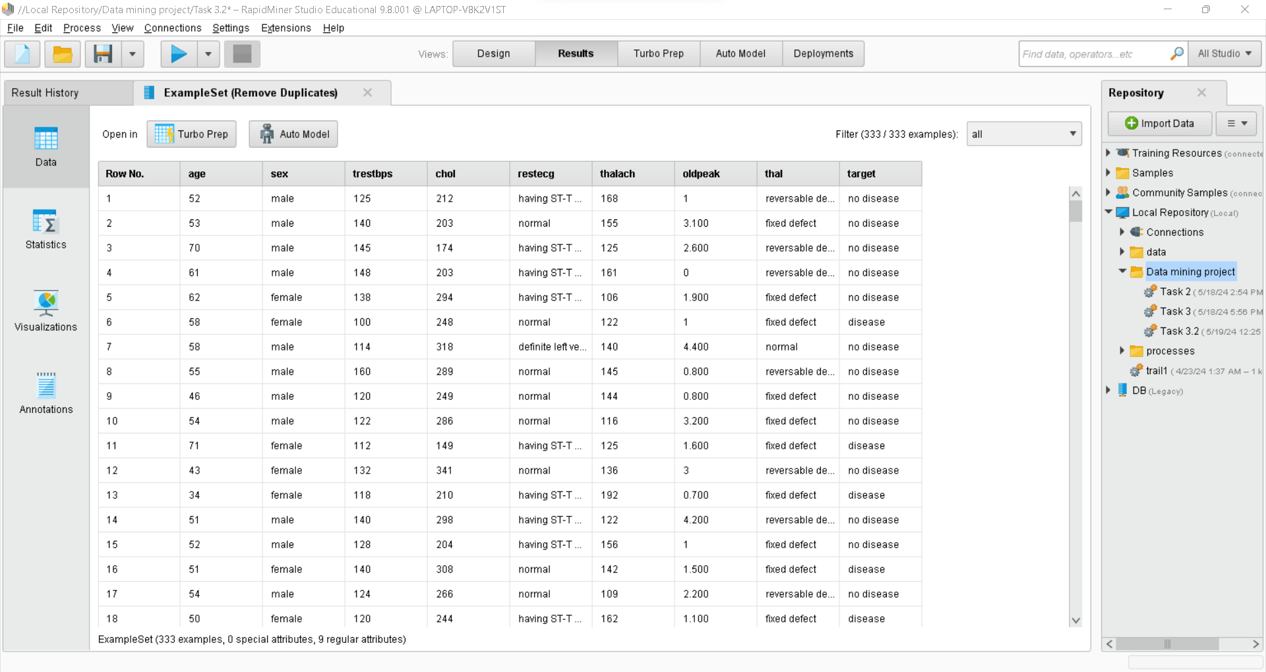

Figure 12: shows the number of instances in the dataset has decreased from 1025 to 333, and the number and the number of attributes has been decreased from 14 to 9.

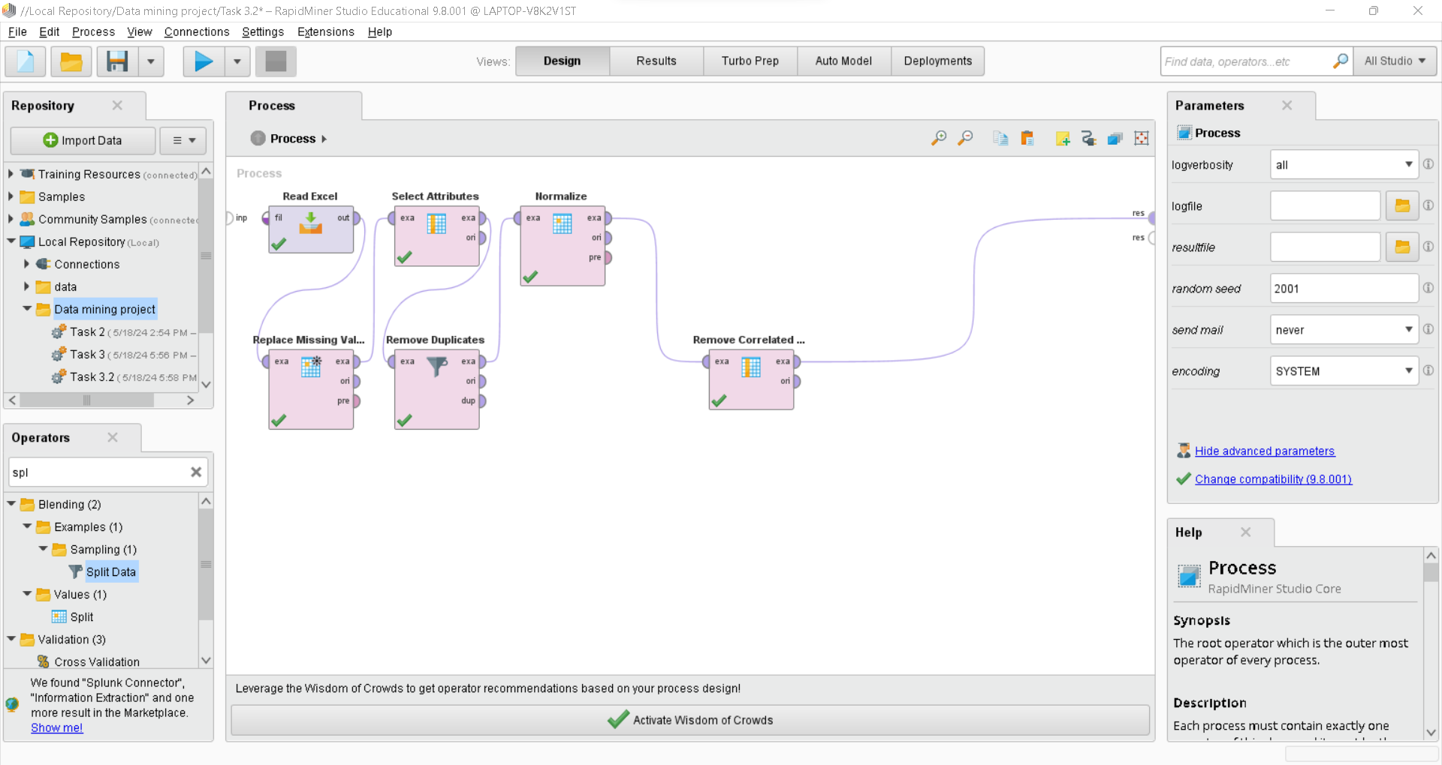

Figure 13: shows the usage of Normalize operator to decrease the range of data and Remove Correlated Attributes operator to insure there will be no overfitting of data.

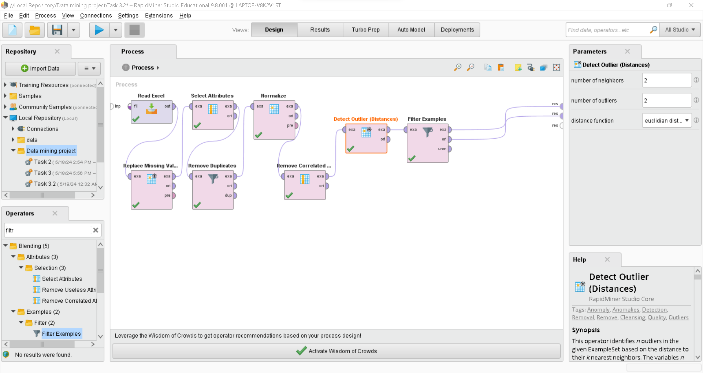

Figure 14: shows the use of Detect Outlier (Distance) operator using Euclidean distance, and Filter Examples operator to find and remove any outliers.

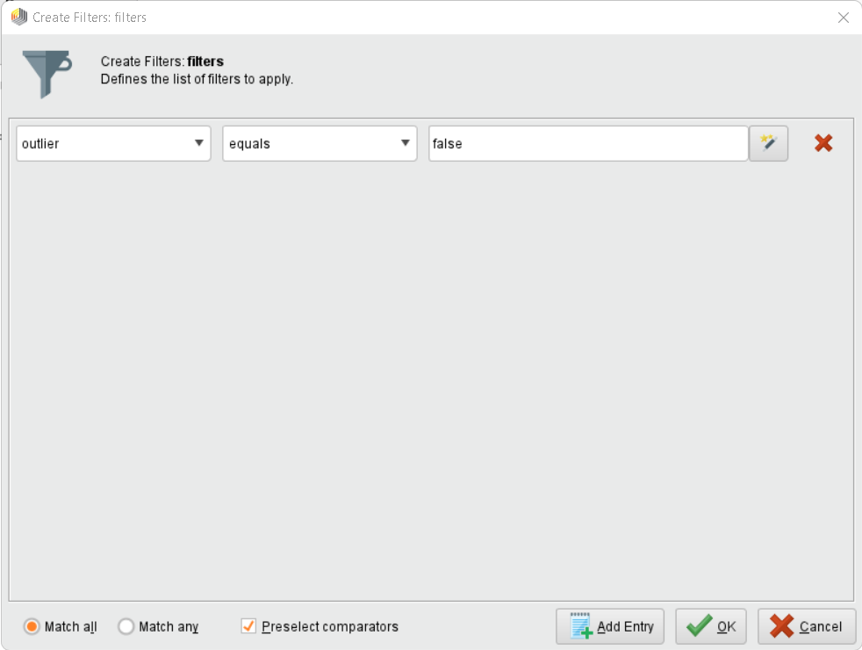

Figure 15: shows the use of Filter Examples operator to through the condition which says that if the outlier is equal to false the instance will be remaining otherwise if the outlier is equal to true after applying the filter the row having an outlier will be removed.

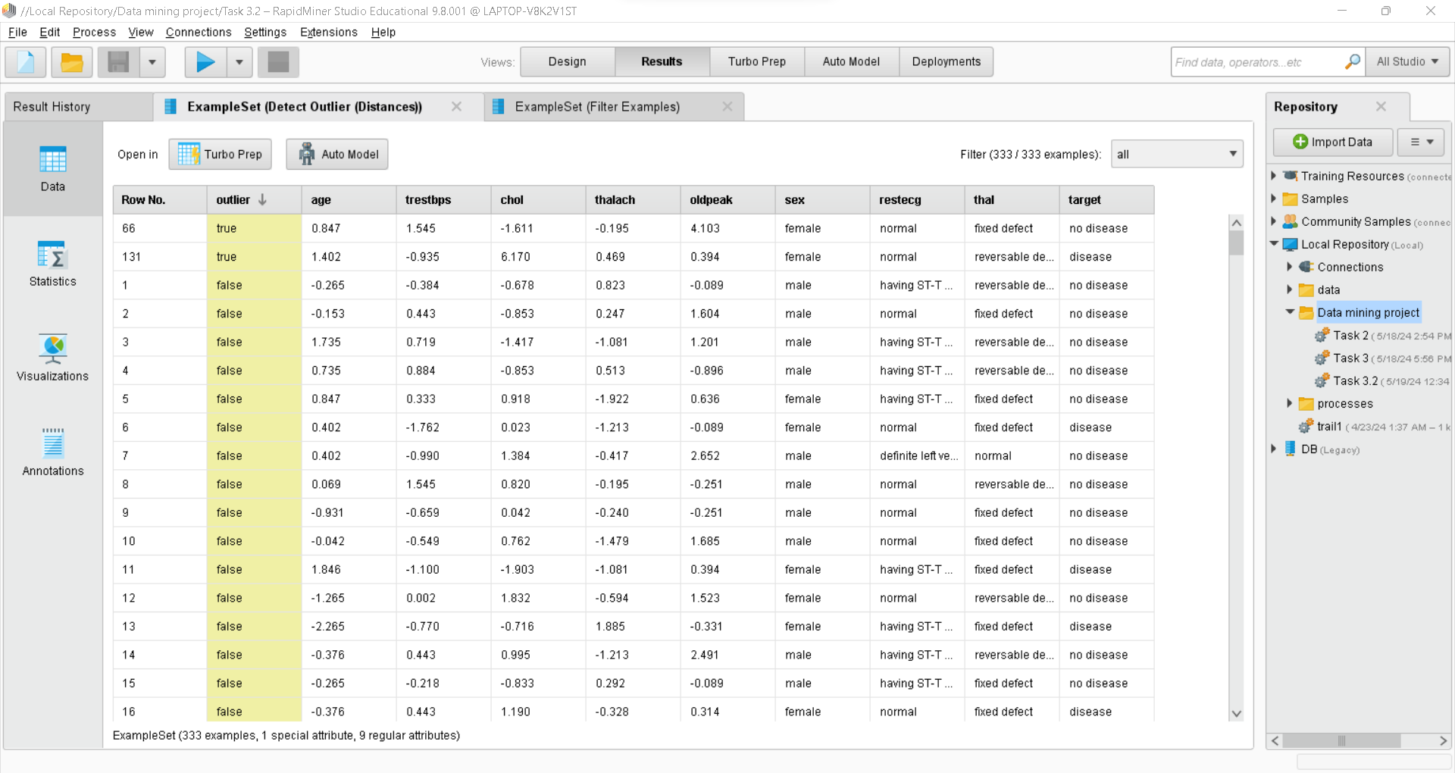

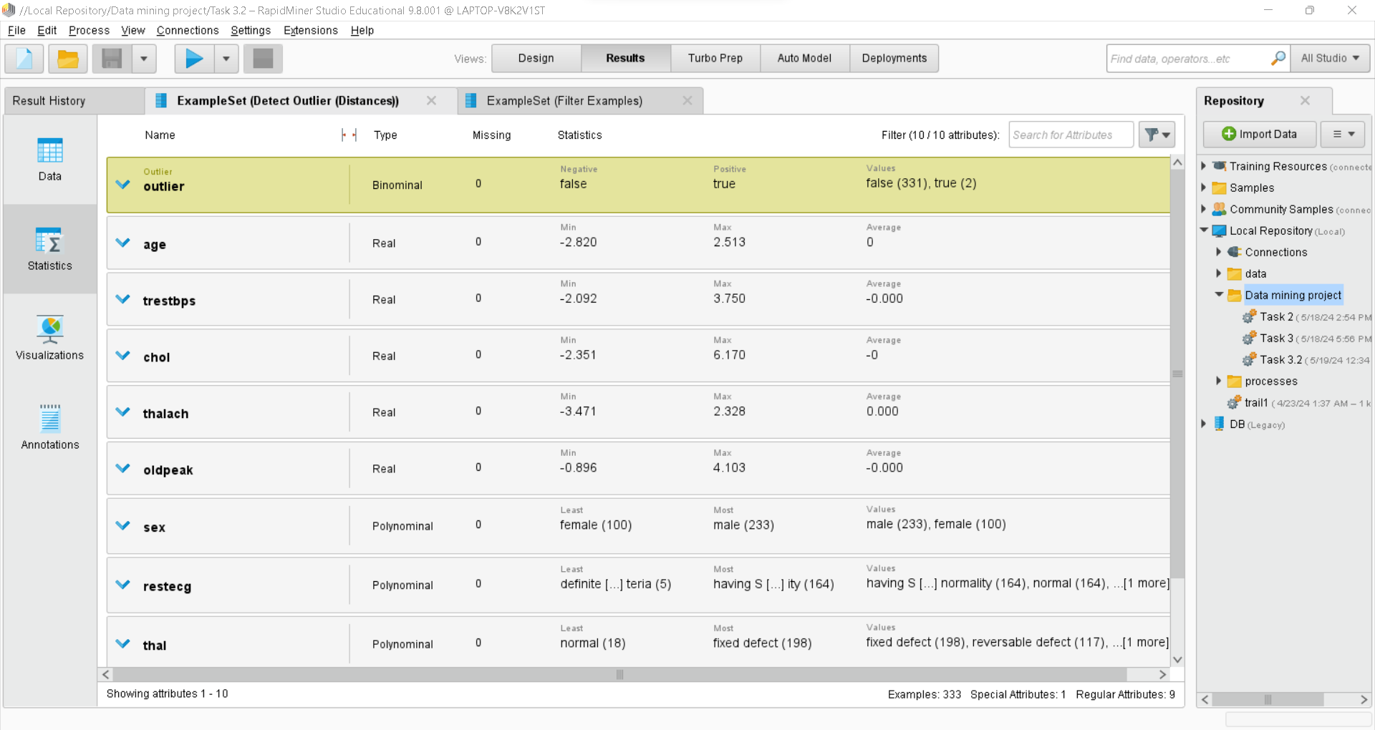

Figure 16: shows the detection of the outliers before applying the filter and removing them.

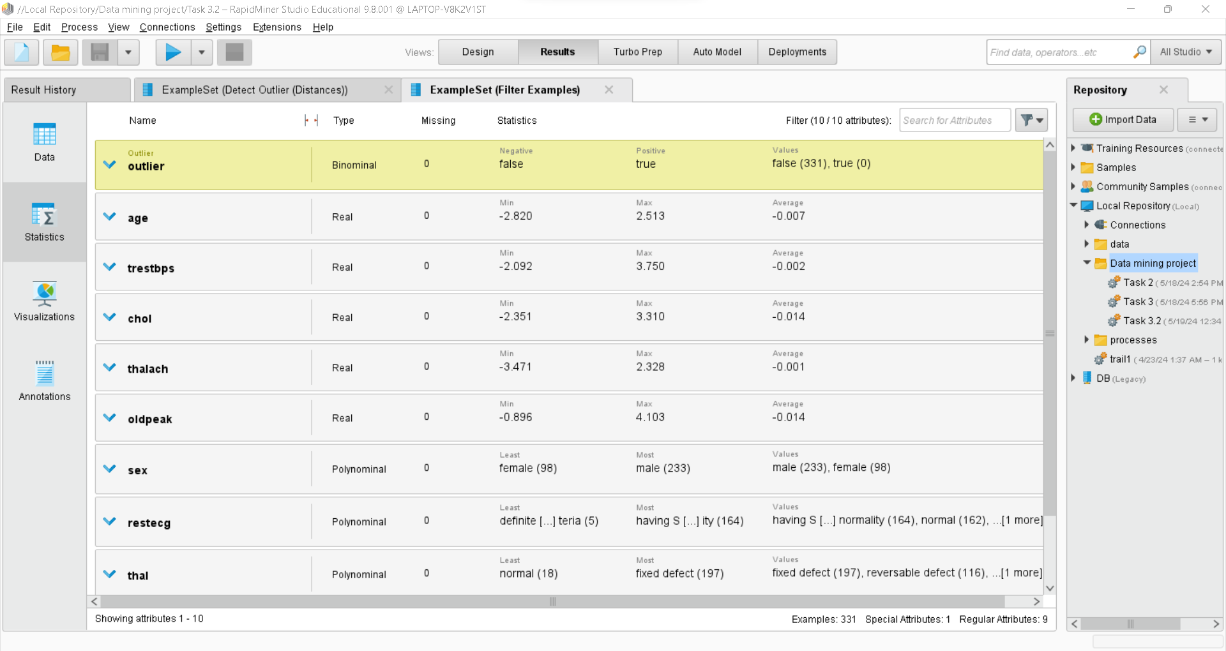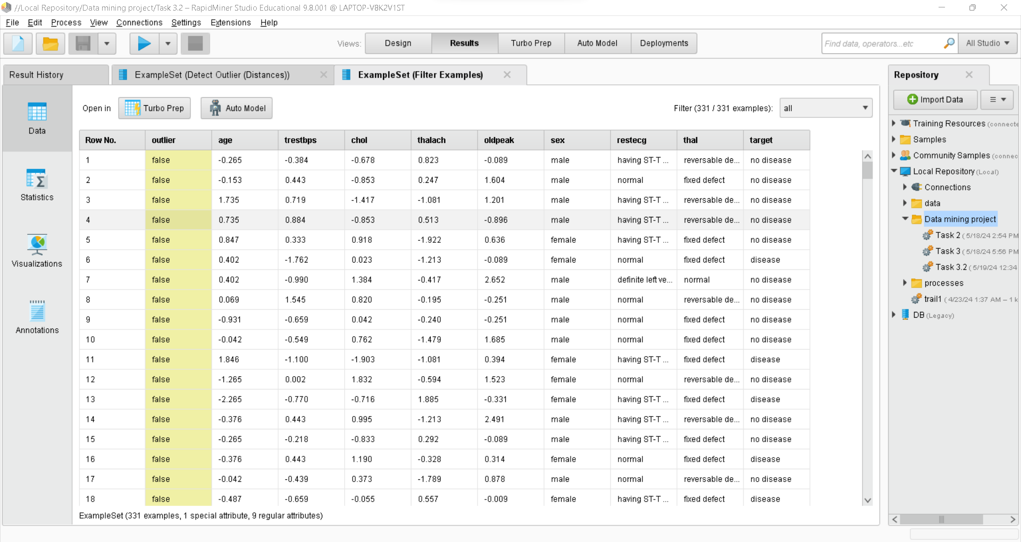

Figure 17: shows data after applying the filter and removing the outliers.

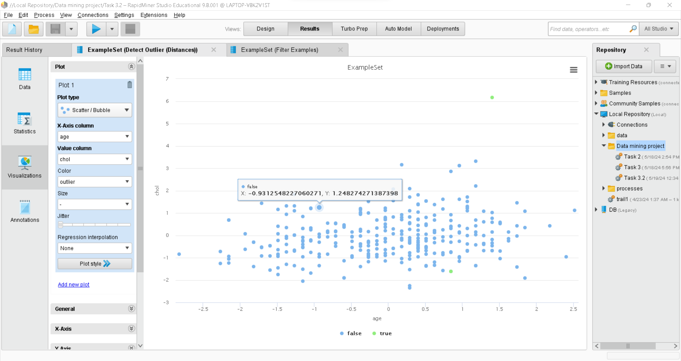

Figure 18: shows a visualization of data before removing the outliers.

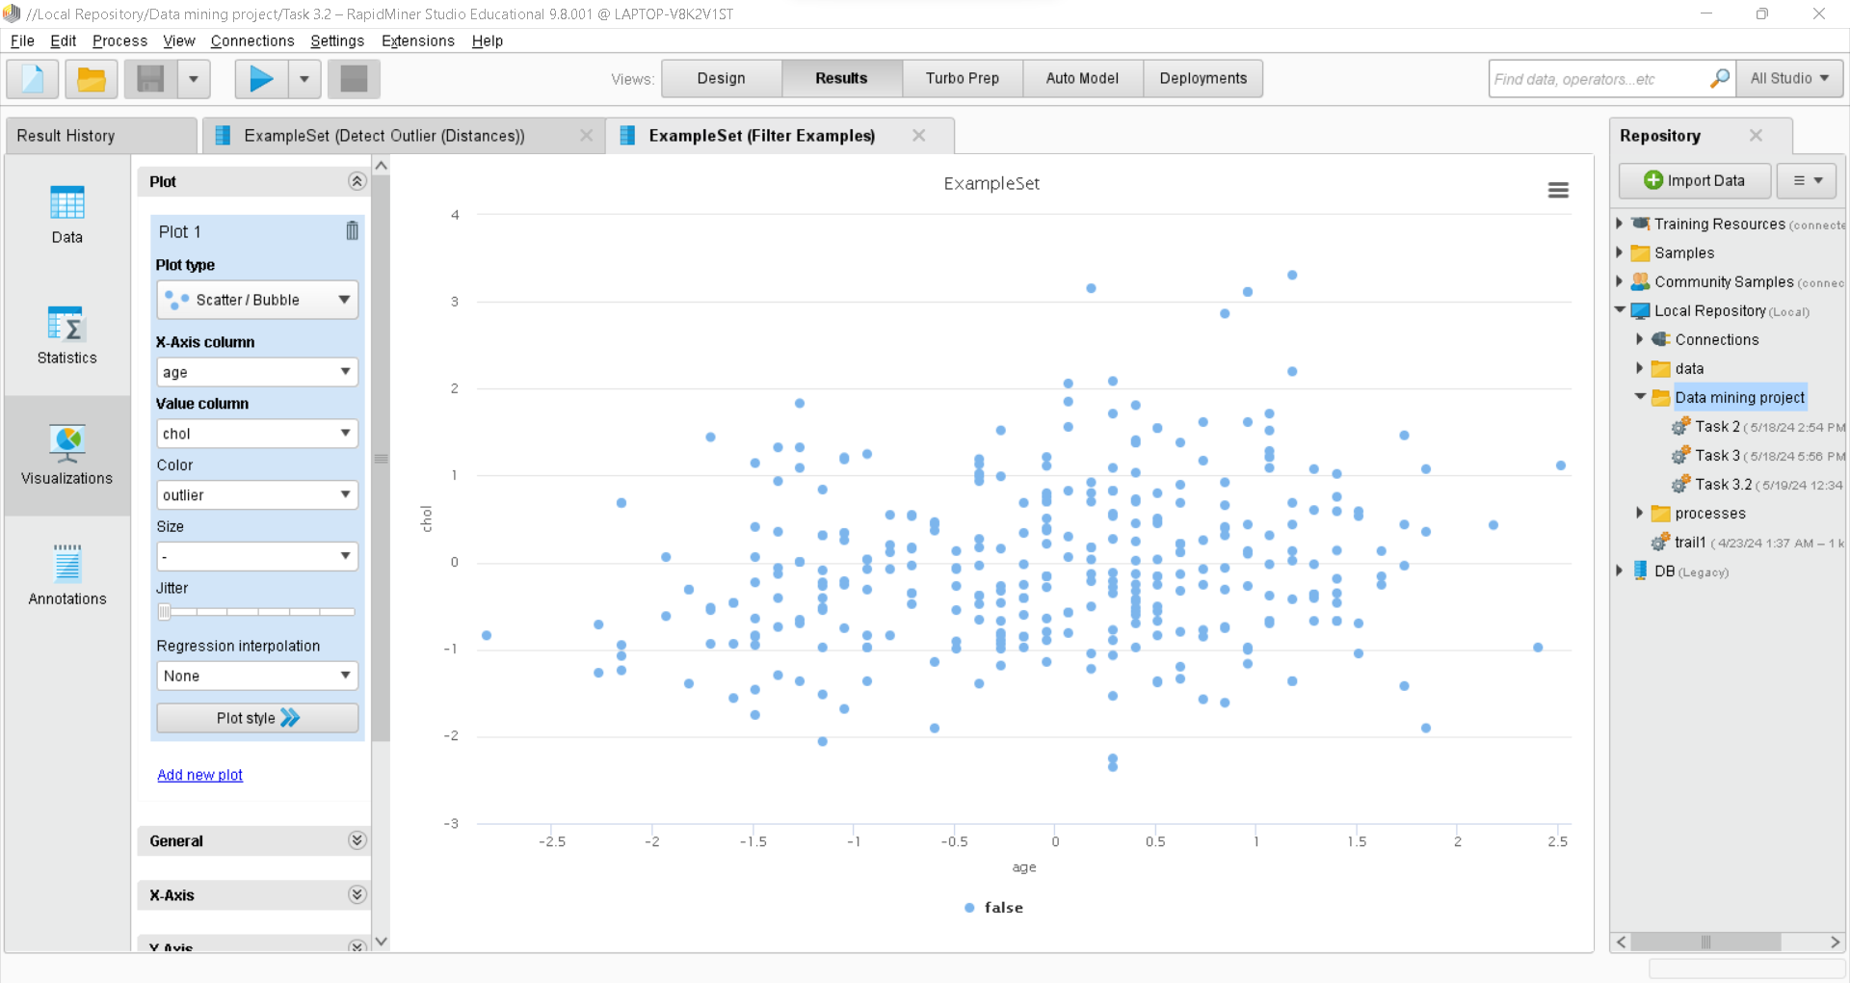

Figure 19: shows a visualization of data after removing the outliers.

**Visualizing data after applying pre-processing techniques:**

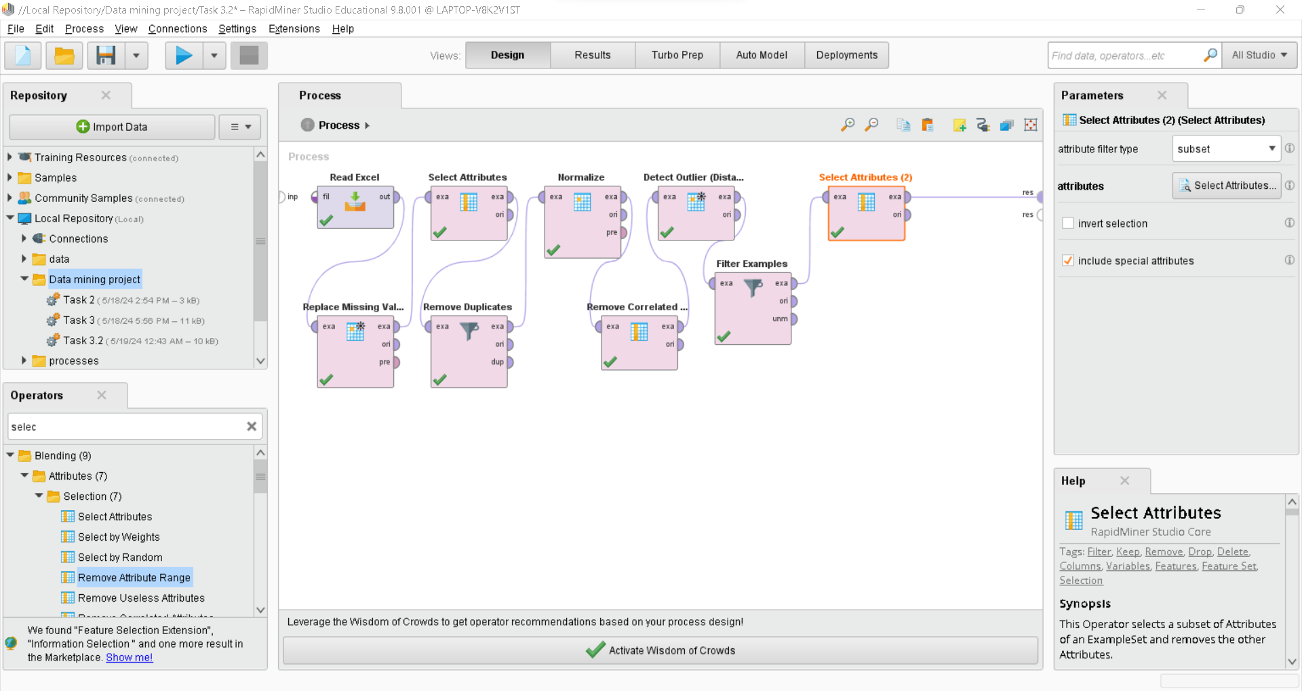

Figure 20: shows the use of Select Attributes operator to remove the outlier attribute from the dataset.

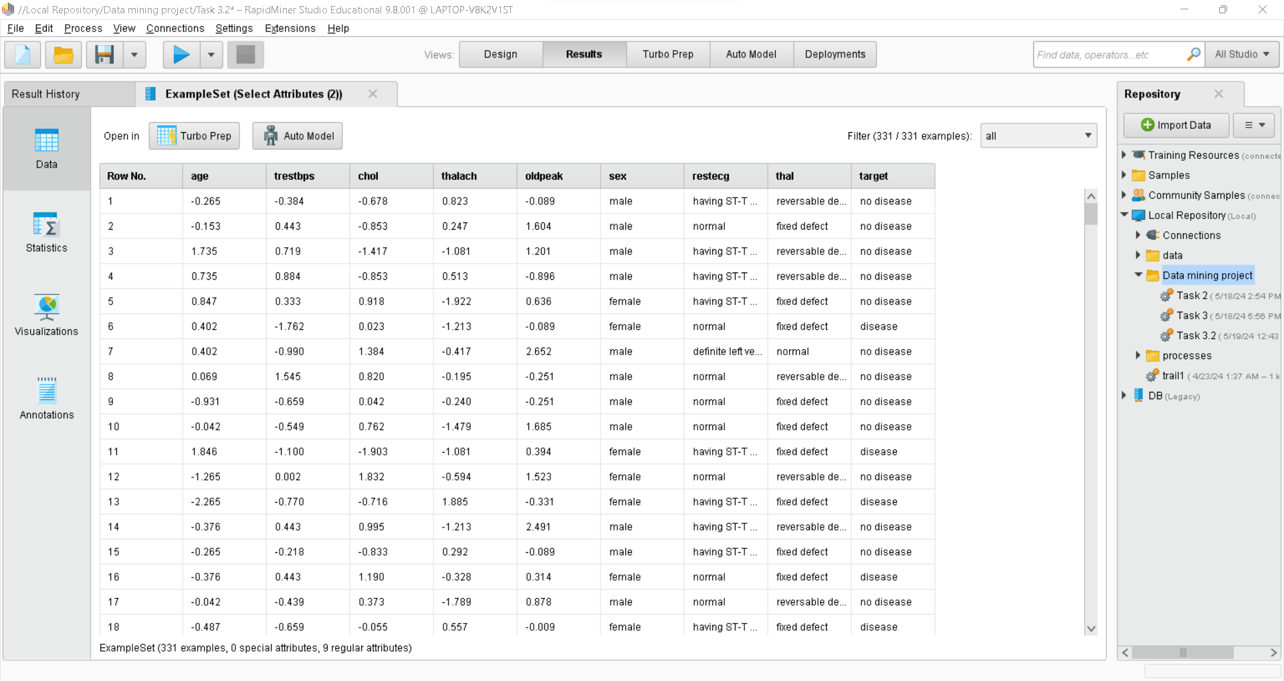

Figure 20: shows pre-processed data.

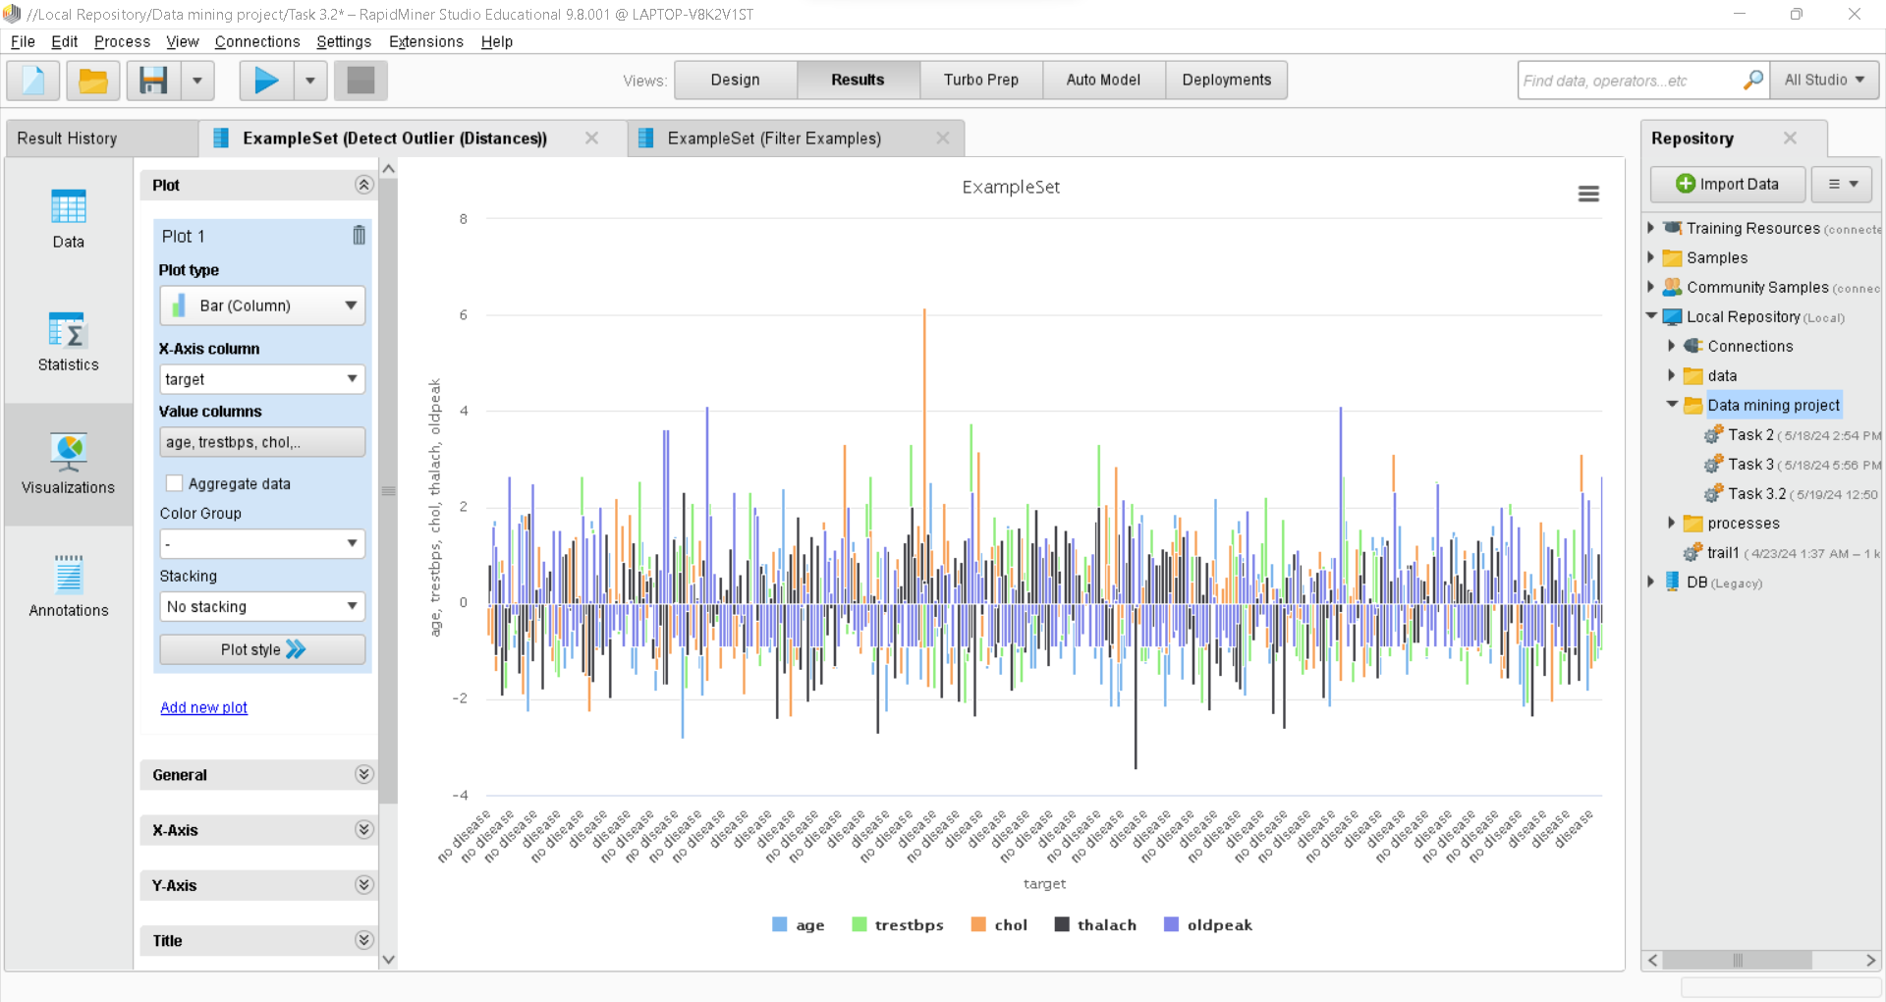

Figure 21: shows the data before cleaning with outliers.

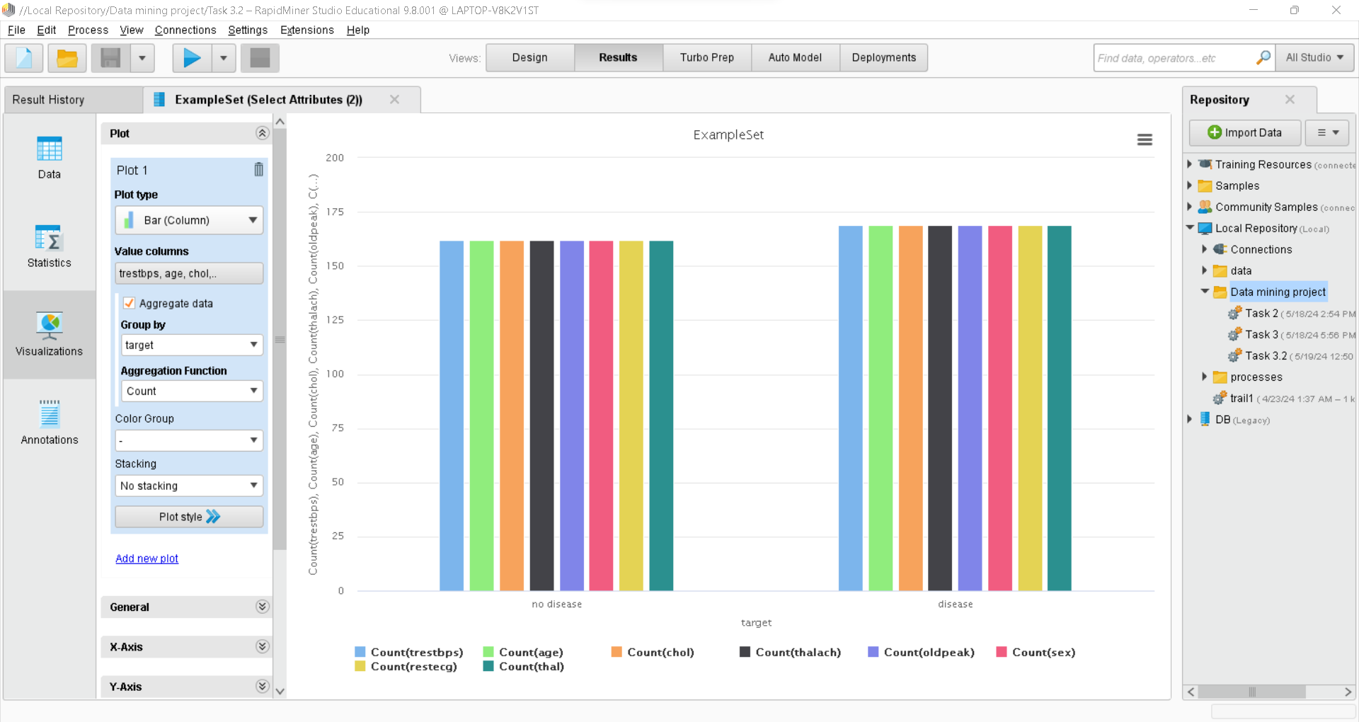

Figure 22: shows the data after cleaning.

# Task 4- Building Data Mining Models

Our model requires a supervised approach as the dataset has an attribute called “target” in it has two values: disease and no disease, so we can say that we have two classes and for this model we will apply classification techniques.

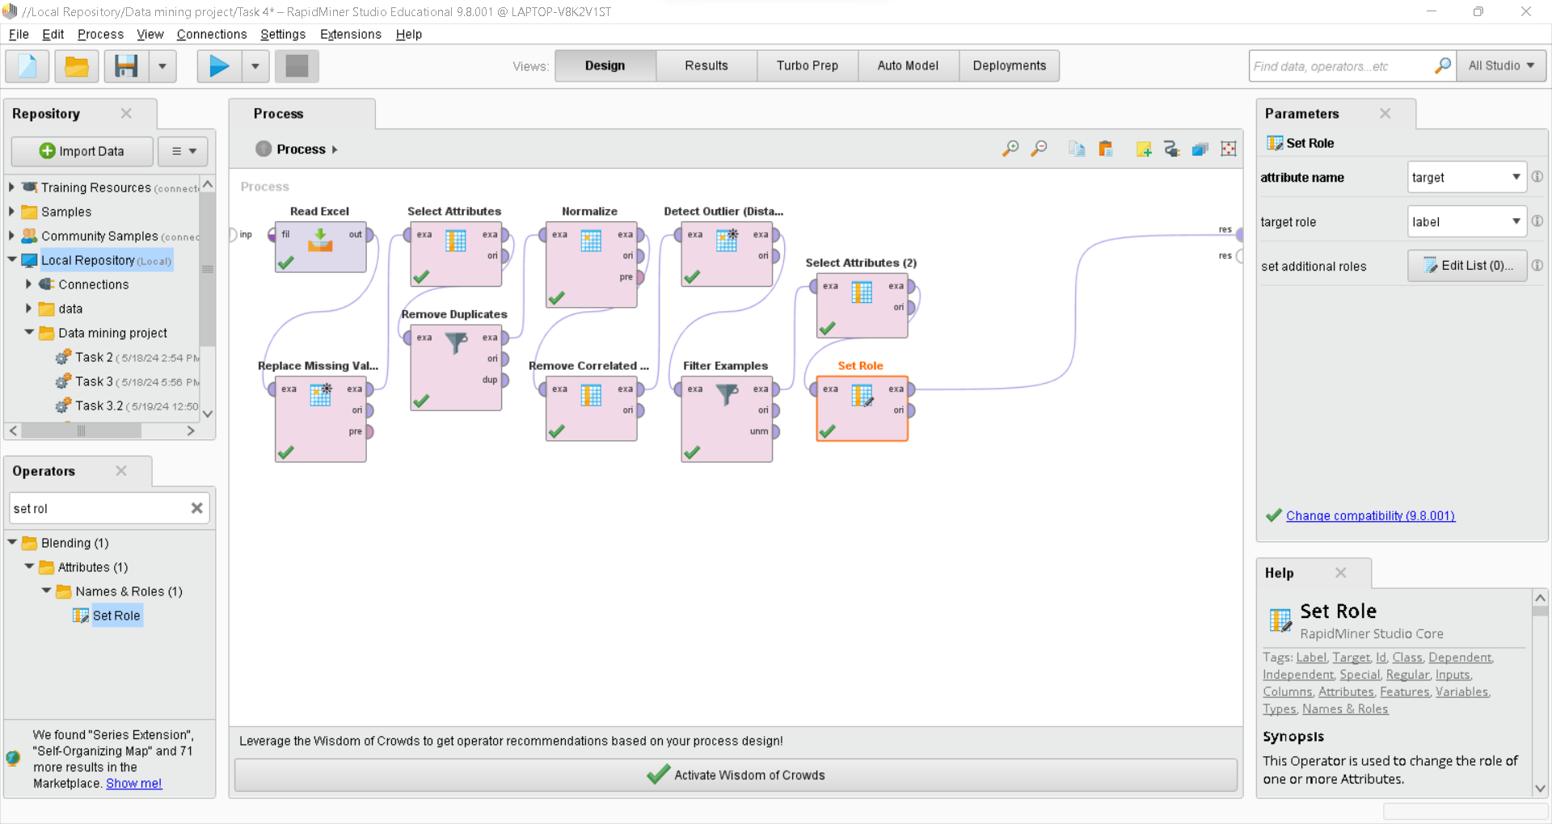

Figure 23: shows the use of Set Role operator with the parameters.

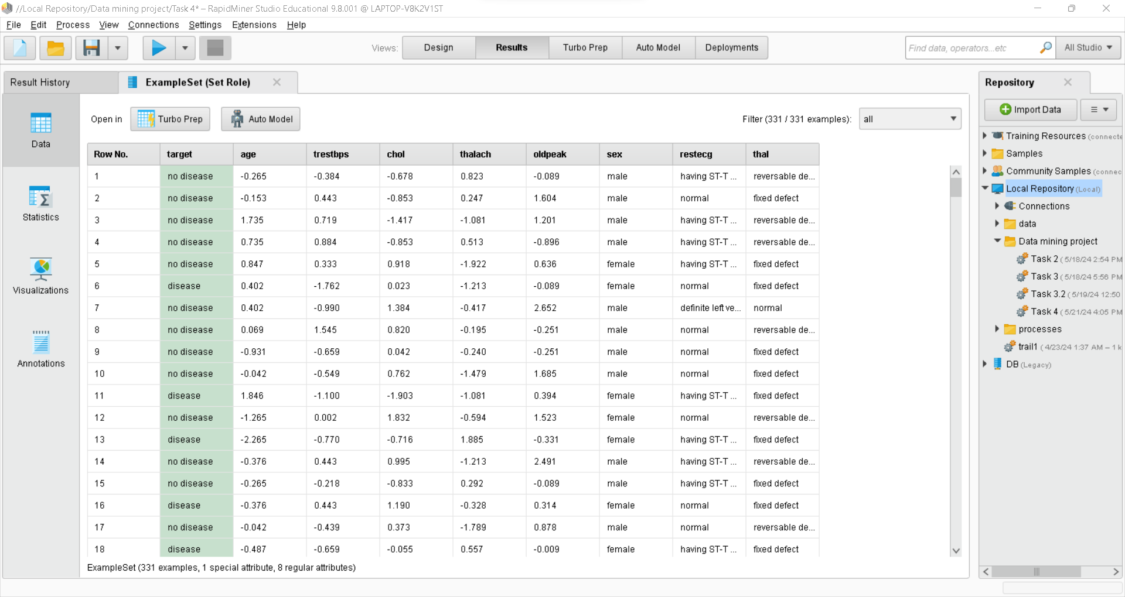  
  
Figure 24: shows the data after applying Set Role operator for supervised model.

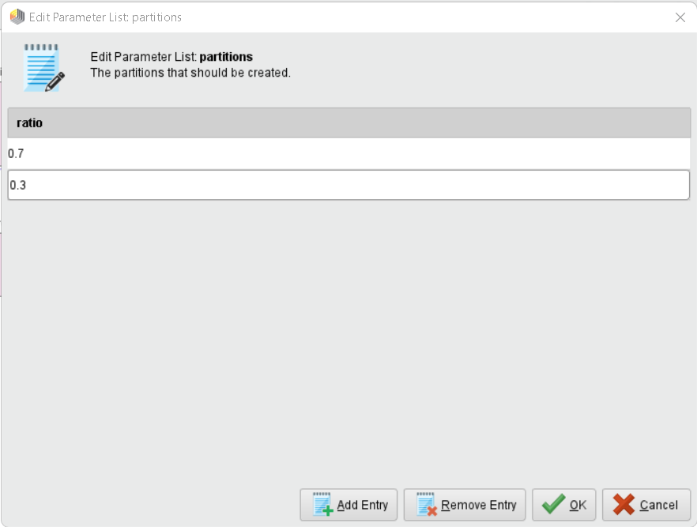

Figure 25: shows the parameter for Split Data operator with 0.7 ratio for training and 0.3 ratio for testing the models.

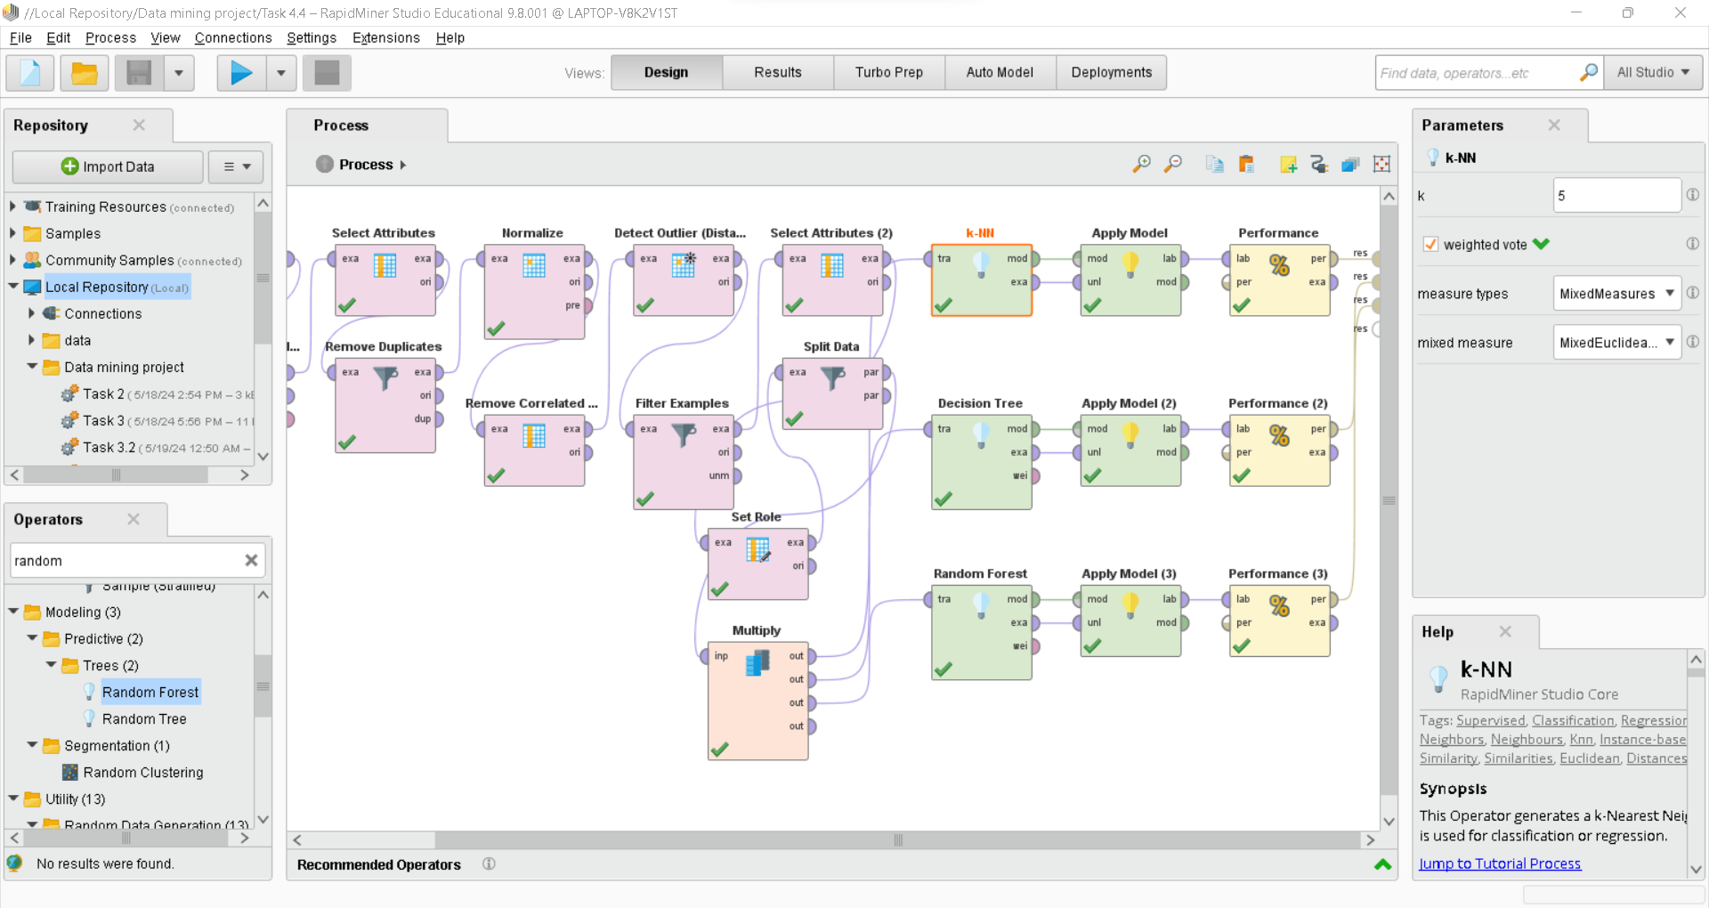

Figure 26: shows the use of Multiply operator to multiply the dataset. Also, it shows the use of K-NN operator with the parameters that has k = 5 for supervised model.

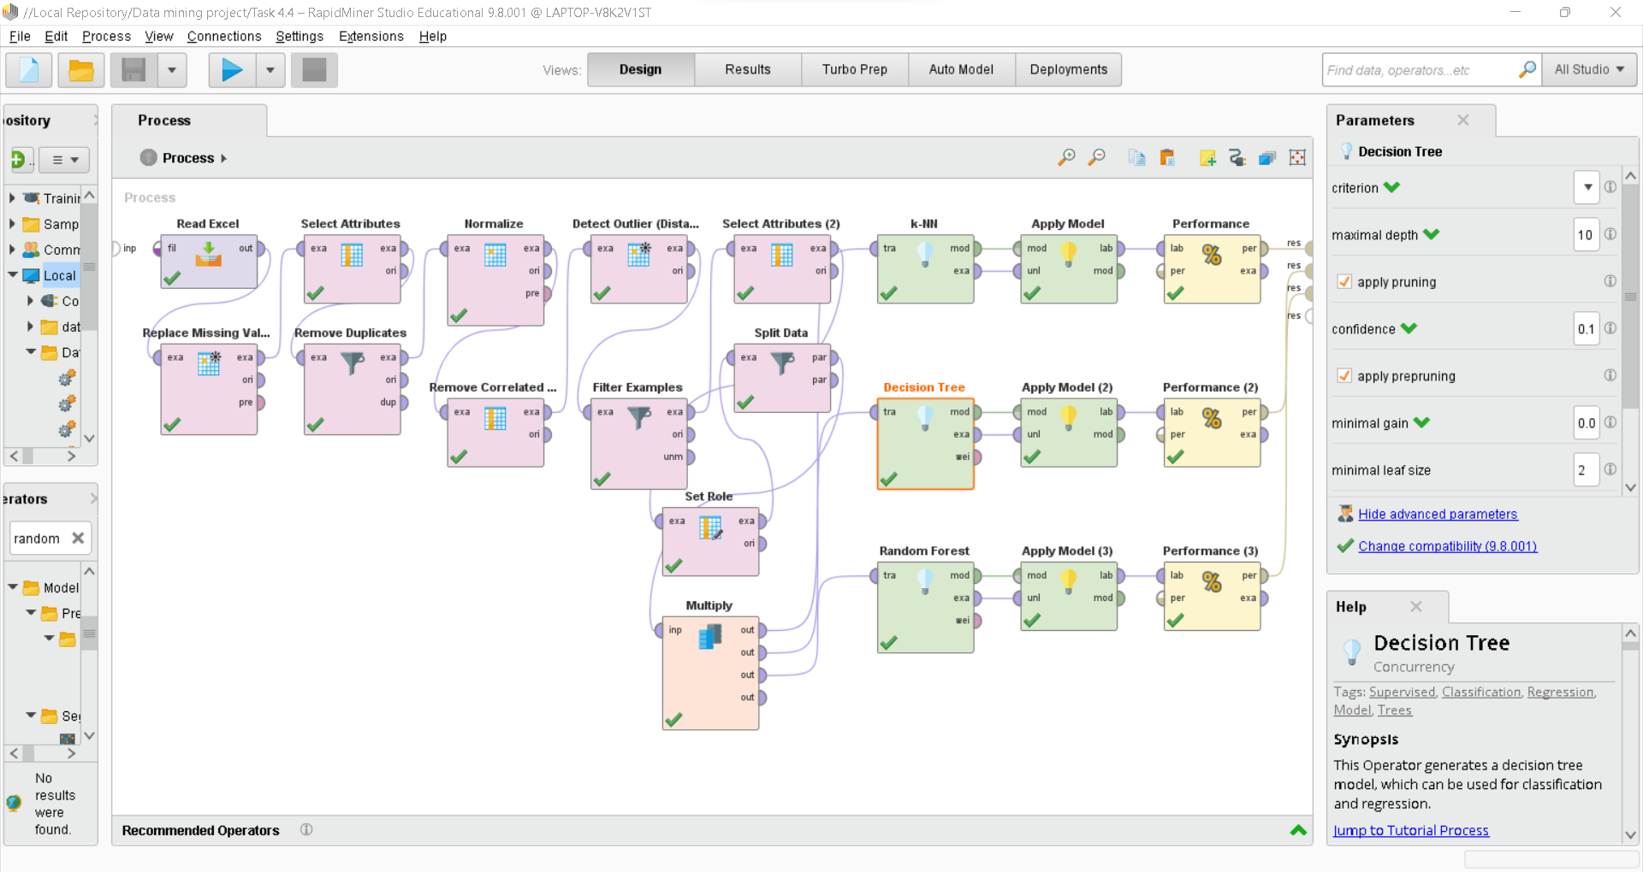

Figure 27: shows the use of Decision Tree operator with the parameters for supervised model.

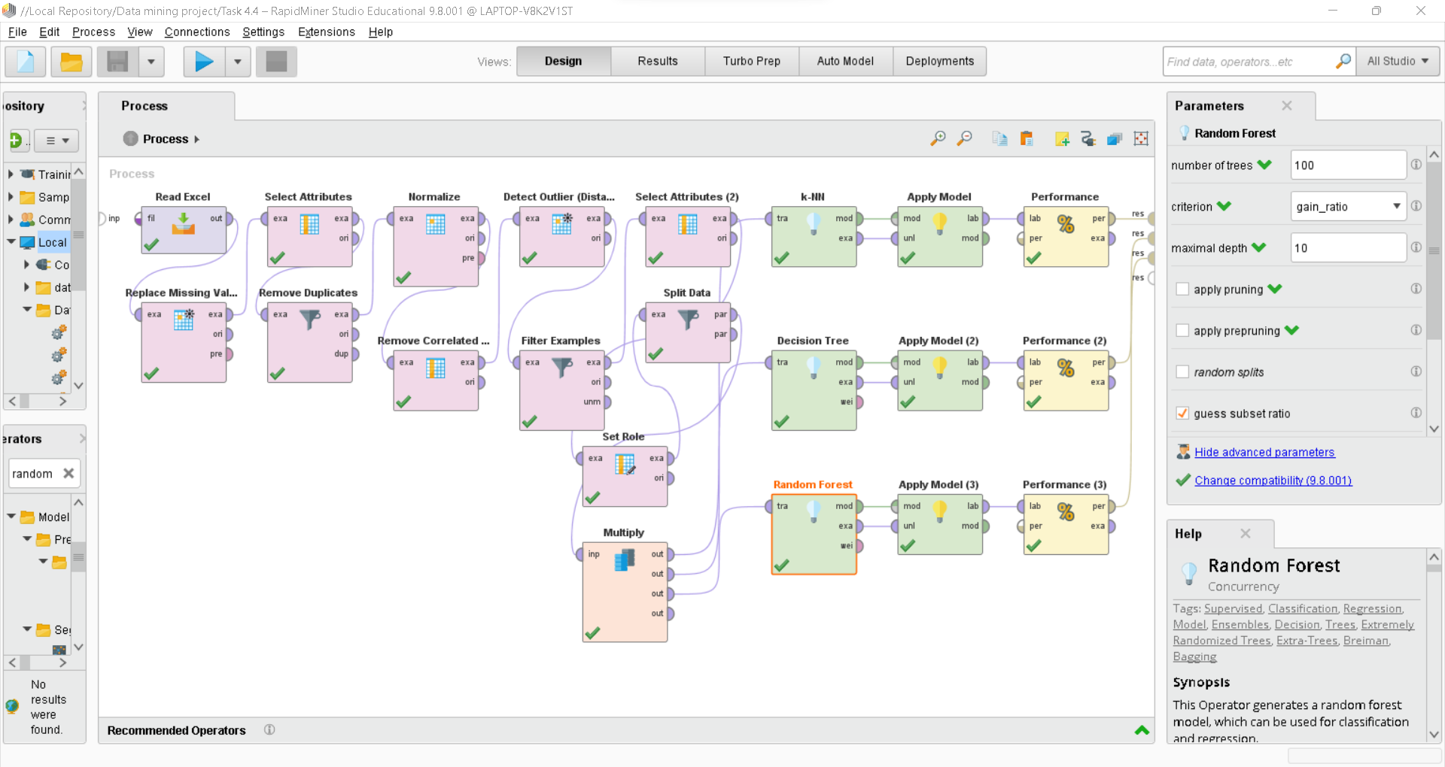

Figure 28: shows the use of Random Forest operator with the parameters that has number of trees = 100 for supervised model.

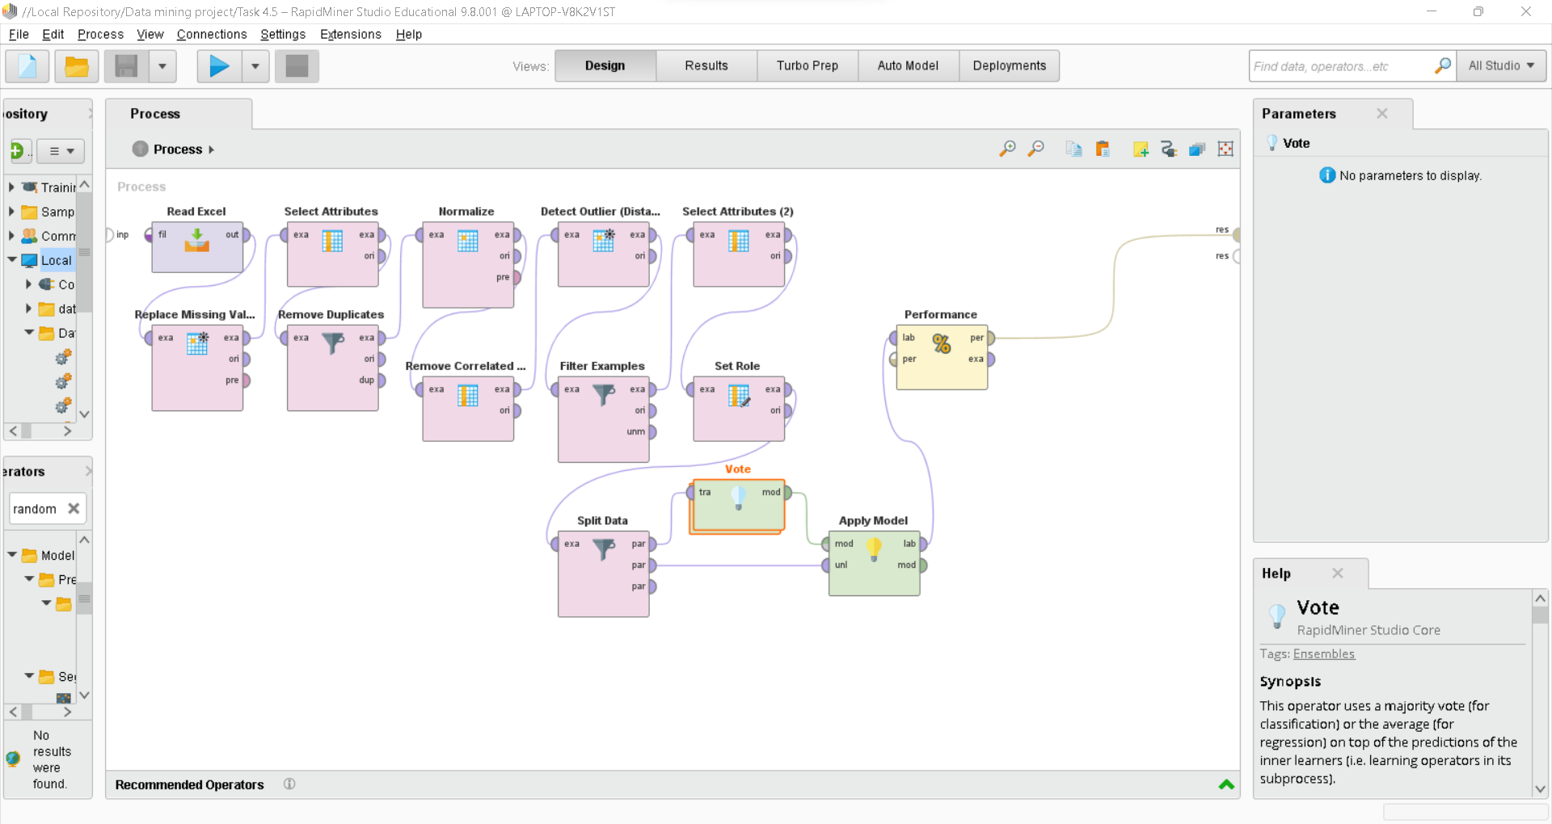

Figure 29: shows the use of Vote operator to apply Ensemble model.



Figure 30: shows the parameter for Split Data operator with 0.7 ratio for training and 0.3 ratio for testing the models.

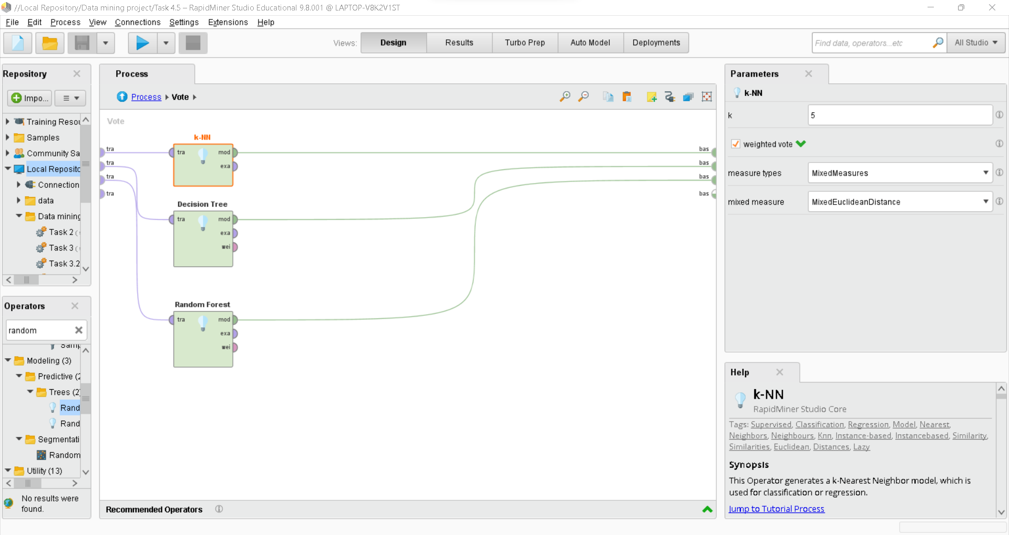

Figure 31: shows the use of K-NN, Decision Tree, and Random Forest operators to apply Ensemble model for the Vote operator.

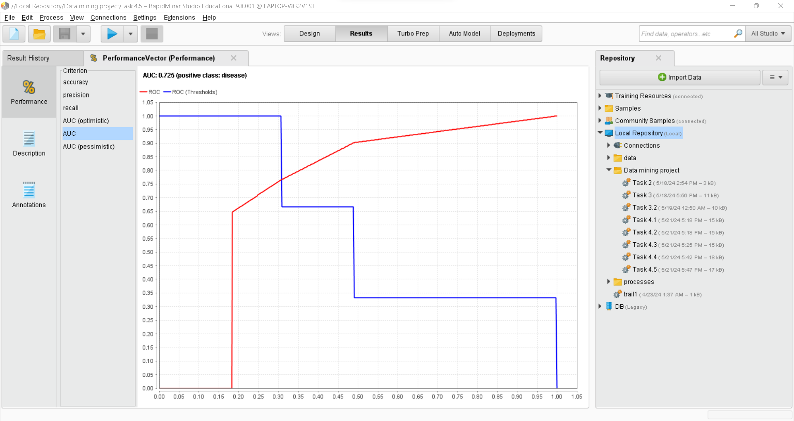

Figure 32: shows a visualization of the AUC for the best model among K-NN, Decision Tree, And Random Forest using Vote operator.

# Task 5 -Evaluating Data Mining Models

## Evaluating Models:

We used a supervised model for our dataset so that we will evaluate the classification techniques such as K-NN, Decision Tree, and Random Forest as well as the Ensemble model the uses vote operator to choose the best approach for our data using different classification methods.

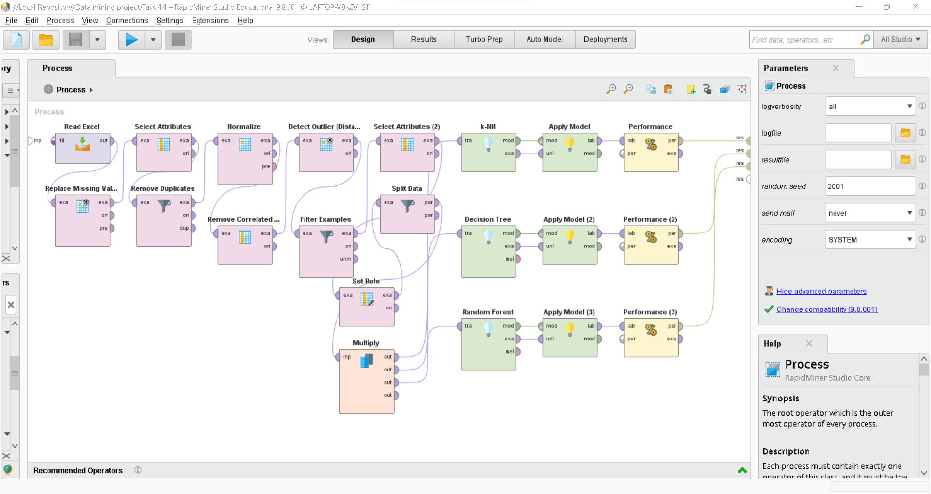

## K-NN Classification Evaluation:

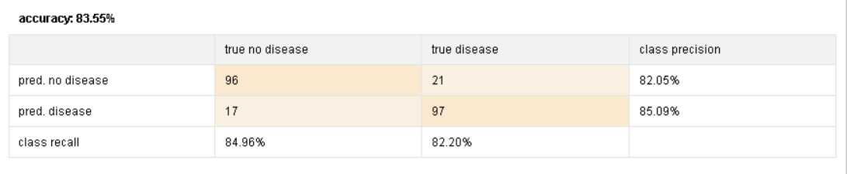

First, K-NN classification technique has been used to check the verification of the testing method if it is appropriate or not. In the above matrix, it is clearly shown that the accuracy is 83.55%. And it shows the max number of errors which is 21.

## Decision Tree Evaluation:

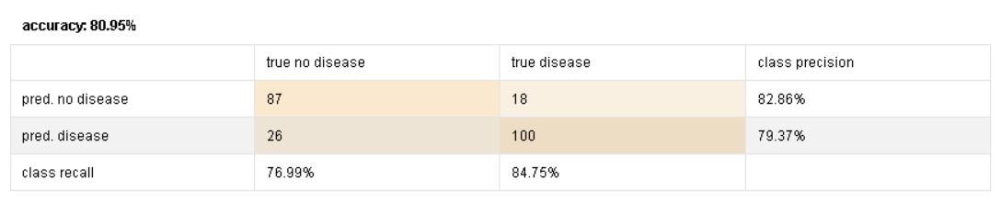

Second, decision tree classification technique has been used to check the verification of the testing method to see if it is appropriate or not. In the above matrix, it is clearly shown that the accuracy is 80.95%. And it shows the max number of errors, which is 26.

## Random Forest:

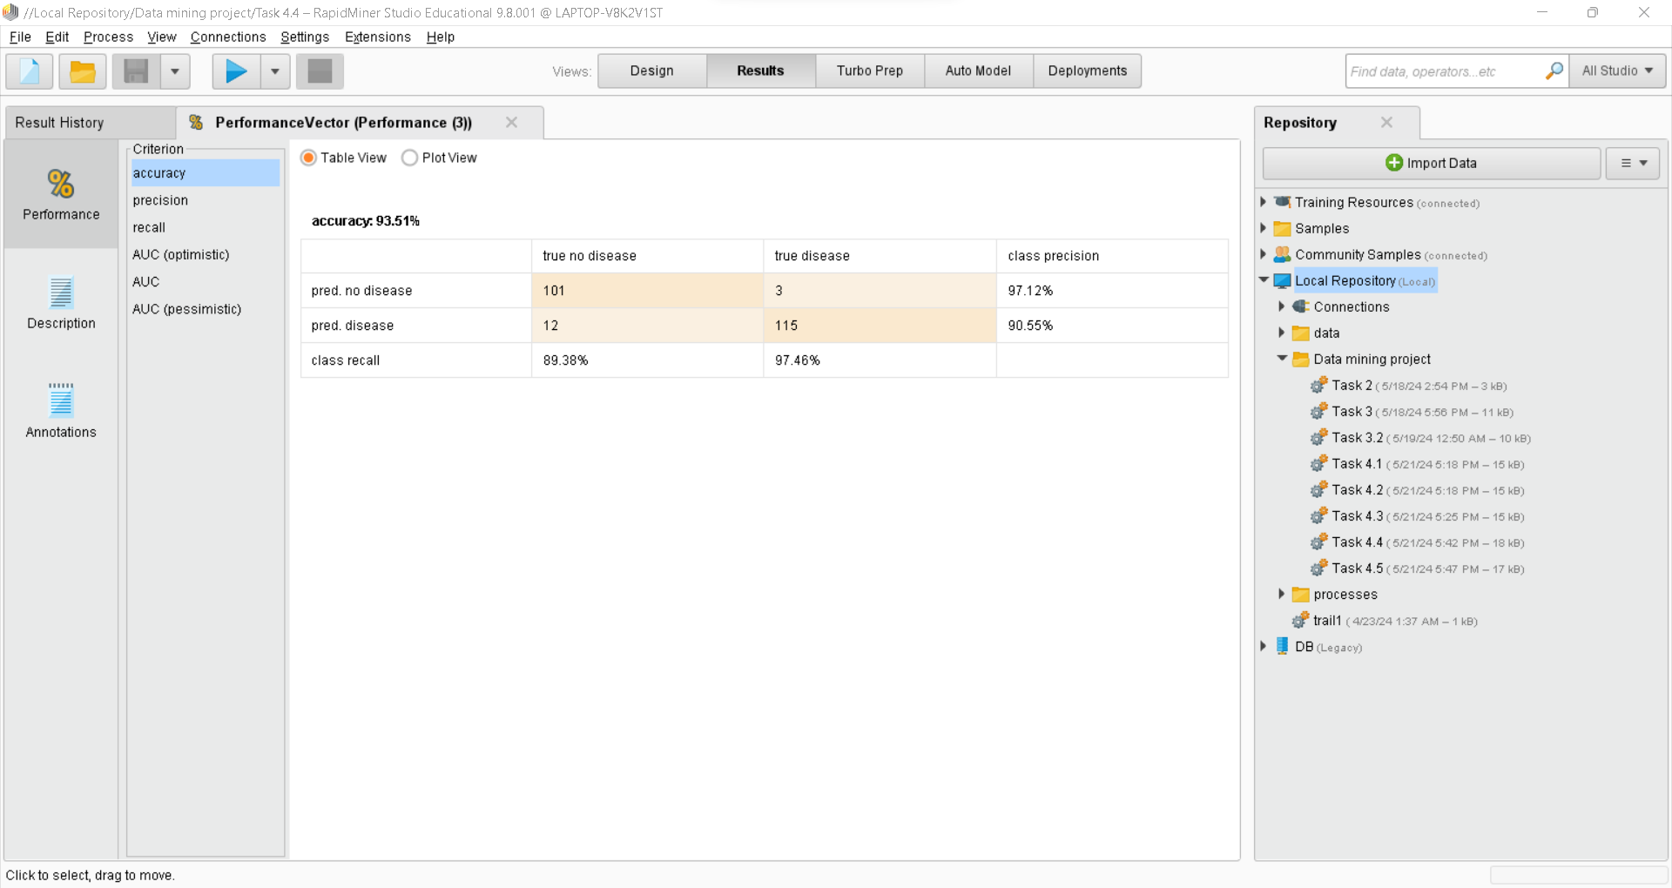

Third, random forest classification technique has been used to check the verification of the testing method to see if it is appropriate or not. In the above matrix, it is clearly shown that the accuracy is 93.51%. And it shows the max number of errors, which is 12, so that we can say that this model is the best for our dataset as it has the highest amount of accuracy.

## Ensemble Model Evaluation:

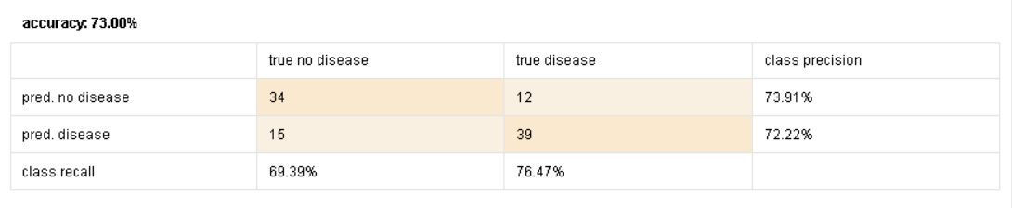

Finaly, the ensemble model will vote for the most accurate algorithm among them (K-NN, Decision Tree, and Random Forest). The above matrix shows a low 73.00% accuracy compared to the actual use of the models as it does the voting and calculation processes to provide the most accurate one. So before applying ensemble model we had 26 error max, however, here we only have 15 max number of errors which are the incorrect classification for some values. As a result, this model will be reliable for further use of data.

# Task 6 – Inferences, Recommendation and Reflection

**Inferences:**

After evaluating our data mining models, we discovered that the Random Forest model performed the best compared to K-Nearest Neighbors (K-NN) and Decision Tree models. Although the ensemble model, which combined these techniques, also did well, it didn't significantly outperform the Random Forest model on its own. The Random Forest model showed the highest accuracy and did well in terms of precision and recall. Our analysis highlighted key factors such as maximum heart rate (thalach), serum cholesterol levels (chol), and resting electrocardiographic results (restecg) as important predictors of heart disease. High prediction accuracy means our models can help with early detection, potentially lowering healthcare costs and improving patient outcomes by identifying heart disease earlier. Visualizing the data before and after preprocessing showed how crucial it is to handle missing values and outliers. Cleaned data presented clearer patterns, which made the model’s predictions more accurate.

**Recommendation:**

Based on our findings, we recommend using the Random Forest model for future heart disease prediction due to its demonstrated superior performance. This model consistently produced the most accurate results in identifying individuals at risk. To ensure the model's continued accuracy, we suggest establishing a regular monitoring and updating schedule. As real-world data and medical knowledge evolve, periodically retraining the model will be crucial to maintain its effectiveness. Additionally, exploring the inclusion of more health-related attributes within the model has the potential to further enhance its predictive capabilities. Factors such as family history, lifestyle choices, and detailed blood work results could provide valuable insights that the current model might not capture. By implementing these recommendations, we can strive for a more robust and reliable tool for heart disease prediction, ultimately aiding healthcare professionals in early detection and improved patient outcomes.

**Reflection:**

This project has been an education in data analysis, particularly highlighting the importance of data cleaning. In this reflection, I'll focus on data sampling: its relevance, the insights it provides, and how it sheds light on the crucial role of data preprocessing in our understanding.

This heart disease prediction project using data mining techniques has been a valuable learning experience. We discovered firsthand the critical role of data preprocessing, as without proper cleaning and normalization, subsequent analysis would have been inaccurate. The data mining process itself yielded valuable insights into heart disease risk factors, informing potential preventive measures. However, the project also highlighted the limitations of single data sources, suggesting future endeavors incorporate data from various sources like electronic health records for a more comprehensive picture. Additionally, ethical considerations around sensitive health data were recognized. Overall, this project has sparked our enthusiasm for exploring data mining's potential in healthcare.

Looking forward, we aim to expand our data mining skillset, utilize diverse datasets to create more robust models, and explore real-world applications that can translate our findings into practical tools for improved patient care. This project served as a steppingstone into the vast world of data mining and its potential impact on healthcare, and we are committed to continuing our exploration and development of data-driven solutions for the fight against heart disease and other complex health challenges.

### Miscellaneous

IT8416 - Data Mining Project Log File.

Project Name: Heart Disease Prediction.

|  |  |  |
| --- | --- | --- |
| Student Member | Student ID | Student Name |
| 1 | 201901982 | Maryam Alali |
| 2 | 202002514 | Fidaa Ali |
| 3 |  | Yaqeen |

|  |  |  |  |  |
| --- | --- | --- | --- | --- |
| Date | Week No | Task Name | Work Done | Issues |
| 11 March 2024 | 1 | Project discussion | planning meeting to explore potential topics, identify data sources, and define team roles. | - |
| 17 March 2024 | 2 | Project Planning | Analyzed project needs, divided the requirements list, and developed a timeline for efficient project delivery. | We had an issue of distributing the tasks because at that time we didn’t have enough knowledge about topics. |
| 31 March 2024 | 3 | Project Implementation | Worked on task 1- Problem Statement Formulation and definition of the project | - |
| 21 April 2024 | 4 | Project Implementation | Worked on task 2 Selection of an Appropriate Data Set and task 3 Preparation and Pre-processing of Selected Data | We used PCA operator, while using we got confused about which attribute has been chosen. Therefor we used (remove Correlated Attribute Operator) to solve the problem. |
| 2 May 2024 | 5 | Project Implementation | Worked on task 4 Building Data Mining Models | - |
| 9 May 2024 | 6 | Project Implementation | Worked on task 5 Evaluating Data Mining Models | - |
| 18 May 2024 | 7 | Project Finalization | Video has been recorded, uploaded to GitHub and completed the project. | Some technical issues while recording the video. Also, we had some errors while uploading the project in GitHub. |

## GitHub Link:

<https://github.com/FedaaAdbdulwahab/Data-mining-project>

## Video Link:

<https://youtu.be/by9FWWHoZYE>

# References:

L,D. (2019). Heart disease dataset. Retrieved from  
<https://www.kaggle.com/datasets/johnsmith88/heart-disease-dataset>

UC Machine Learning Repository. (2019). Heart disease. Retrieved from  
<https://archive.ics.uci.edu/dataset/45/heart+disease>

Utkarsh. (2023). KDD in data mining. Retrieved from  
<https://www.scaler.com/topics/data-mining-tutorial/kdd-in-data-mining/>